Republic of Mauritius
Ministry of Ocean Economy, Marine Resources, Fisheries and Shipping
ANNUAL REPORT ON PERFORMANCE
FOR FINANCIAL YEAR 2018-2019

Table of Contents
Statement from the Honourable Minister 7
Statement from the Permanent Secretary 10
Overview 11
Vision and Mission 11
Key Objectives 11
Core Values 12
Our Customers 12
Services offered by the Ministry 12
Departments, Parastatals and Others 13
Departments 15
Parastatals and Council 30
Gender Statement 31
About our people 31
Organisational Chart 32
Contact Details of Senior Officials 33
Scarcity Areas 36
Training 37
Major Achievements 39
Aquaculture Division 39
Competent Authority Seafood (CASF) 41
Fisheries Protection Service 41
Fisheries Training and Extension Centre (FiTEC) 44
Laboratories Division 45
Marine Conservation Division 47
Marine Resources Division 48
Marine Science Division 53
Monitoring, Control and Surveillance/ Vessel Monitoring System/ Port State Control/ Import/ Export Division 56
Planning and Licensing Division 60
Shipping Division 61
Mauritius Maritime Training Academy 64
Budget Measures 66
Key Actions 67
Events 68
Implementation Plan – Director of Audit Comments for FY 2018-2019 71
Financial Highlights 74
Statement of Revenue 74
Vote 20-1 Ocean Economy, Marine Resources and Shipping 79
Vote 20-2 Fisheries 80
Analysis of Major Changes 81
Revenue 81
Expenditure 81
Trends and Challenges 83
Strategic Direction 84
List of Acronyms 85
List of Figures
Figure 1 – Vision and Mission of the Ministry 11
Figure 2 - Core Values of the Ministry 12
Figure 3 - Services offered by the Ministry 12
Figure 4 - Departments and Parastatals of the Ministry 13
Figure 5 - Location of Departments of the Ministry 14
Figure 6 - Fisheries Posts of the Ministry 14
Figure 7– Main Objectives of Parastatal Bodies and Council 30
Figure 8 - Deployment of staff members of the Ministry 31
Figure 9 - Organigram of the Ministry 32
Figure 10 - Seining operation 40
Figure 11 - Sampling of freshwater prawn 40
Figure 12 - Statistics from Fisheries Protection Service 42
Figure 13 - Initiating trainee fishers to use sail 44
Figure 14 - Trainee fishers participating in deployment 44
Figure 15 - FAD deployed at sea to attract migratory pelagic fish 45
Figure 16 - Marine Chemistry Laboratory at the AFRC 45
Figure 17 - Membrane Filtration technique for analysis of coliform bacteria 46
Figure 18 - Pre-treatment of marine biota for radionuclides analysis 47
Figure 19 - Monthly catch by fishery - Offshore demersal fishery project 49
Figure 20 - No. of Exhibits examined from July 2018-June 2019 50
Figure 21 - Sampling of Octopuses before closure of Octopus Fishery (2018) 51
Figure 22 - Best Octopus catch on re-opening of Octopus Fishery (2018) 51
Figure 23 - The third purse seiner “Belouve” joined the fishery in January 2019 52
Figure 24 - Tuna being unloaded by small longliners 52
Figure 25 - Coral Reef Monitoring 2018-2019 54
Figure 26 - Hands-on Training on Marine turtle to UOM Students 55
Figure 27 – Marine Turtle treatment at AFRC 55
Figure 28 - Verification of Gross Mass 61
Figure 29 - Collection and Analysis of Samples 62
Figure 30 - Guests and Participants at the Opening Ceremony 68
Figure 31 - “Day of the Seafarer” celebrated at MMTA on 04 July 2019 69
Figure 32 – Actual Revenue for FY 2017-2018 and FY 2018-2019 76
Figure 33 - Actual Expenditure for FY 2018-2019 78
Figure 34 - SWOT Analysis of the Ministry – Strengths and Weaknesses 83
Figure 35 - SWOT Analysis of the Ministry - Opportunities and Threats 83
List of Tables
Table 1- Details of Grades falling under scarcity areas 36
Table 2- Statistics from Competent Authority Seafood 41
Table 3 - Fine inflicted in breach of Fisheries Act 42
Table 4 – Statistics on number of cases and amount collected as fine 43
Table 5 - Import of fish and fish products for FY 2018-2019 58
Table 6 - Export of fish and fish products for FY 2018-2019 59
Table 7- Statistics from Shipping Division for period July 2018 to June 2019 63
Table 8 - Statistics for Financial Year 2018-2019 64
Table 9 - Budget Measures for FY 2018-2019 66
Table 10 - Key Actions for FY 2018-2019 67
Table 11- Implementation Plan – Director of Audit Comments 2018-2019 72
Table 12 - Statement of Revenue of the Ministry 74
Table 13 - Statement of Expenditure of the Ministry 77
Table 14 - Statement of Revenue for Vote 20-1 “Ocean Economy, Marine Resources and Shipping” 79
Table 15 - Statement of Expenditure for Vote 20-1 “Ocean Economy, Marine Resources and Shipping” 79
Table 16 - Statement of Revenue for Vote 20-2 “Fisheries” 80
Table 17 - Statement of Expenditure for Vote 20-2 “Fisheries” 80

- At the Ministry of Ocean Economy, Marine Resources, Fisheries and Shipping

Statement from the Honourable Minister
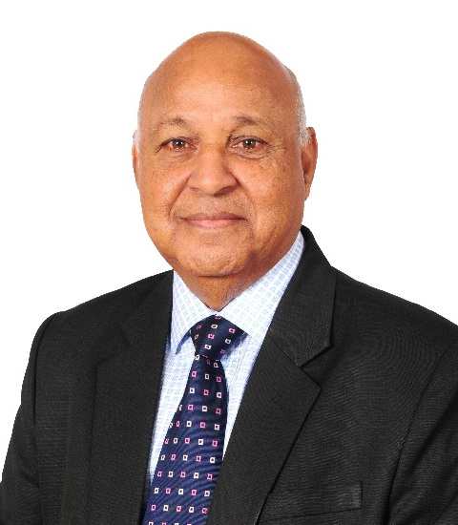
I am pleased to present the Annual Report for the Ministry of Ocean Economy, Marine Resources, Fisheries and Shipping for the Financial Year 2018-2019. The vision of the Government is to make the Ocean Economy a new economic pillar in the coming years for economic growth and job creation. In this regard, the Ministry is committed to give all the necessary boost and support to develop the Ocean Economy sector.
During the Financial Year 2018-2019, the Ministry has spared no effort to implement the various measures and projects which include amongst others the setting up of coral nurseries and rehabilitation of degraded coral reefs, implementation of the “Canotte” and “Semi-Industrial” Fishing schemes, preparation of the new Fisheries Bill which will incorporate international norms and practices so as to modernize the fisheries sector. Moreover, nine new fishing boats joined the demersal chilled fish fishery. The Ministry has also started promoting coral farming by fishermen and SMEs by setting up sea-based coral farms for developing ornamental corals for the tourism sector, aquarium market and high-end jewellery manufacturing.
The protection and conservation of marine resources remain a priority for the Ministry. In this regard, the two-month octopus closure from 15 August to 15 October was continued and some 600 mangrove propagules were planted at Pointe D’Esny so as to protect coastal zones, create fish breeding areas and build resilience against climate change. The Marine Ranching Project which aims at enhancing the stock of fish in the lagoon was pursued. A collaborative project, “Restoring marine ecosystem services by rehabilitating coral reefs to meet a changing climate future” between Mauritius and Seychelles amounting to USD 10 M, was approved in October 2018 by the Adaptation Fund Board.

The Fisheries sector remains one of the mainstays of the Ocean Economy and according to Statistics Mauritius, local fish production has increased from 25,471 tonnes in the Financial Year 2017-2018 to 31,087 tonnes in the Financial Year
2018-2019, representing an increase of 22 %. Furthermore, domestic export of fish and fish preparations generated revenue of Rs10 billion for the Financial Year
2018-2019.
Much emphasis is being put on aquaculture development given that it is one of the clusters identified to develop the Ocean Economy, to increase local fish production so as to be less dependent on imports besides ensuring food security. To this end, my Ministry has embarked on new aquaculture projects such as aquaponics, sea cucumber and cage culture. Floating cages had been provided to fishermen cooperative societies free of charge under the Floating Cage Culture project and about 500 Kg of fish was harvested from the cages. An increase in aquaculture production from 1,551 tonnes in the Financial Year 2017-2018 to 2,636 tonnes in the Financial Year 2018-2019 was also noted.
The services of a consultant have been enlisted under the Australian Food Aid Programme to work on the sea cucumbers project. Furthermore, the culture of two commercially viable freshwater ornamental fish species namely, the fancy betta-Betta spendens var. and the Cherry barb/Rosy barb (Puntius titteya) were undertaken by the Aquaculture Division and some 330 fingerlings of ornamental fish were successfully produced during the Financial Year 2018-2019. Furthermore, training course on ornamental fish culture will be dispensed to cooperative societies interested in ornamental fish farming.
One of the strategic priorities is the reinforcement of maritime surveillance to combat Illegal, Unreported and Unregulated (IUU) fishing. Thus, the Ministry intends to embark on the implementation of an Electronic Catch Reporting system (ERS) which consists of receiving real time catch data of fishing vessels operating in the mauritian waters. This would allow a better control of the local and foreign fishing vessels operating in the Exclusive Economic Zone (EEZ) of Mauritius.

A new multi-purpose support vessel named the Investigator II is under construction in Australia. The vessel is 18.4 m in length and 5.4 m in width. The total cost for the acquisition of the multipurpose support vessel is estimated at Rs. 57 M and it is being partly funded by the Government of Mauritius and partly by the Government of Australia under its Australian Food Aid Programme. The vessel will be used for the training of fishers, survey of marine resources, stock assessment and research programmes.
In line with the vision of Government to empower and improve the livelihood of fishers, the Fisheries Training and Extension Centre of my Ministry trained some 73 fishmongers in ‘Fish Handling, Preservation and Marketing’ and dispensed training in ‘General Course for Fishers’ to 34 fishers during the Financial Year 2018-2019.

Honourable Premdut KOONJOO
Minister of Ocean Economy, Marine Resources, Fisheries and Shipping

Statement from the Permanent Secretary
As Permanent Secretary, I am deeply honoured to present the Annual Report on Performance of the Ministry of Ocean Economy, Marine Resources, Fisheries and Shipping for the Financial Year 2018-2019.
With Ocean Economy identified as one of the pillars of its economic development, the Ministry of Ocean Economy, Marine Resources, Fisheries and Shipping plays a pivotal role in leading to the transformation of Mauritius into a high-income economy by 2025 and for achieving more economic development in line with the 2030 Agenda of Sustainable Development.
The release of this Annual Report on Performance of the Ministry for the Financial Year 2018-2019 takes us one step closer to disseminating our activities, achievements and challenges, particularly in the “Maritime Century” and in the face of an erratic environment.
During the Financial Year 2018-2019, the Ministry of Ocean Economy, Marine Resources, Fisheries and Shipping made a wave of progress. The Ministry has made significant efforts to implement the setting up of coral nurseries and rehabilitation of degraded coral reefs, implementation of “Canotte” and “Semi-Industrial Fishing” schemes amongst others, that commensurate with its objectives.
On another score, the Ministry has enlisted the services of a consultant under the Australian Food Aid Programme to work on the sea cucumber project. This Ministry also intends to embark on the implementation of an Electronic Catch Reporting System which consists of receiving real time catch date of fishing vessels operating in the Exclusive Economic Zone of Mauritius.
Lastly, I convey my appreciation to the staff of the Ministry for their commitment, devotion and commendable accomplishments during the period under review as well as the editorial team of this report.
I wish you a pleasant reading.
Mr Virendra Kumarsingh DABY
Permanent Secretary

Overview

Vision and Mission
Figure 1 – Vision and Mission of the Ministry

To optimize in a sustainable manner, the immense potential of our Exclusive Economic Zone and develop the ocean economy as a new pole of growth

To make the Ocean Industry an important pillar for sustaining economic diversification, job creation and wealth generation

Key Objectives
The key objectives of the Ministry are to:
- promote the development of economic activities in the ocean industry;
- promote sustainable development and management of fisheries through the adoption of an ecosystem approach and consolidation of aquaculture;
- support the maritime industry and the global trading fleets by expanding the training capacity of the Mauritius Maritime Training Academy in emerging fields of ocean economy;
- develop the shipbuilding/repair industry and promote the services available; and
- characterise the oceanic and coastal environment of the Republic of Mauritius with a view to ensuring optimal long-term exploitation of the marine resources.

Core Values

Figure 2 - Core Values of the Ministry

Our Customers
The customers of the Ministry are the fisher community, the fishing industry, ship owners, shipping agents, seafarers’ welfare associations, the maritime industry, maritime training institutions, oceanography experts, coastal zone users,
non-governmental organisations, the public sector, the private sector, researchers, students, international partners/lending institutions and the public at large.

Services offered by the Ministry

Figure 3 - Services offered by the Ministry

Departments, Parastatals and Others
Parastatals/Council
Departments

Parastatals/Others
Departments

Departments (ctd)

Parastatals
Figure 4 - Departments and Parastatals of the Ministry
Departments
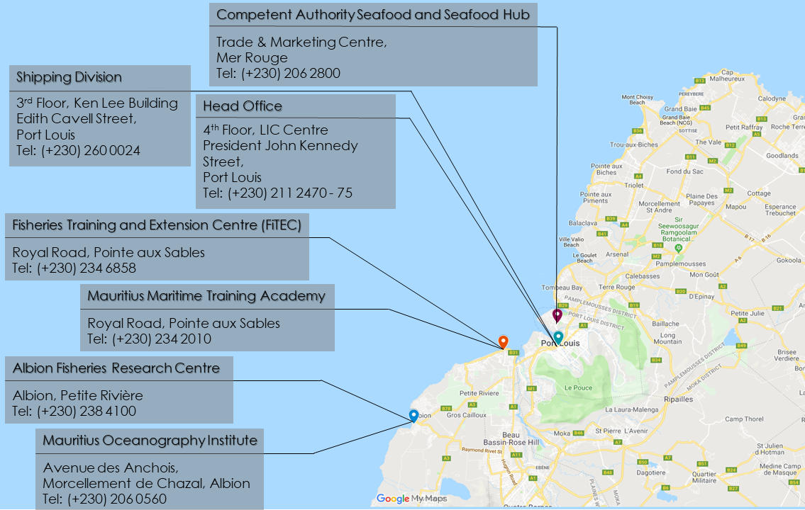
The Departments of the Ministry and their locations are as mentioned in Figure 5.
Figure 5 - Location of Departments of the Ministry
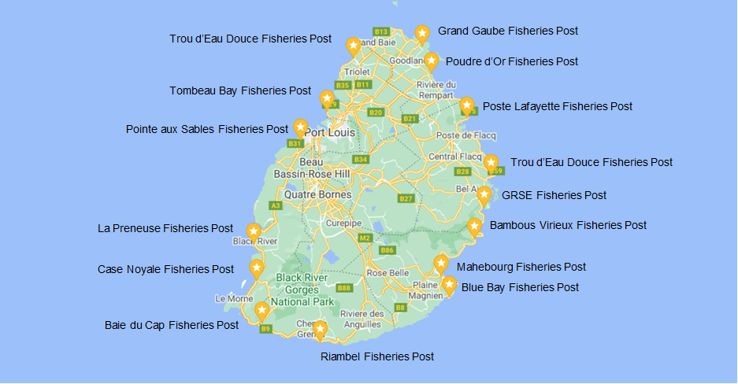
Figure 6 - Fisheries Posts of the Ministry

Departments

The Fisheries Division comprises the Albion Fisheries Research Centre, Aquaculture Division, Marine Resources Division, Marine Science Division, Marine Conservation Division, Laboratories Division, Fisheries Training and Extension Centre, Licensing and Planning Division, and the Monitoring Control Surveillance and Import/Export Division.
The Aquaculture Division is responsible for the promotion and development of aquaculture with a view to increasing fish production through research on different marine and freshwater species. It is also involved in the dissemination of information on aquaculture and provision of technical advice and support to different stakeholders. It facilitates and monitors aquaculture projects, release of fingerlings for stock enhancement and implementation of the cage culture project.
The Aquaculture Division deals with the following projects:
- Freshwater Prawn Seed Production;
- Red Tilapia Hybrid (Berri Rouge) Fingerlings Production;
- Seabream Seed Production;
- Floating Cages for Fishermen Cooperatives;
- Live Feed Production (Plankton Culture);
- Marine Ranching;
- Aquaponics Demo;
- Barachois;
- Extension Services;
- Aquaculture – Fish Farming Zones (Large Scale Production);
- Sea Cucumber Trial;
- Mangrove Crab (Scylla serrata) Seed Production; and
- Training in Ornamental Fish Breeding.

The Division is responsible for carrying out research, development and management of the fishery resources in a sustainable manner for the benefit of all stakeholders of the fisheries sector and the public at large. It is also responsible for development activities aimed at increasing knowledge on the fishery resources found in our Exclusive Economic Zone (EEZ) with a view to enabling its sustainable utilisation. The Marine Resources Division deals with the following projects:
(i) Coastal Fishery
1,914 registered artisanal fishers and 2,127 registered boats were actively involved in the artisanal fishery as at 30 June 2019. They operated in the shallow water lagoons and outer lagoons of Mauritius. 179,609 kg of fresh fish were landed along the coast of Mauritius at 61 Fish Landing Stations during the Financial Year 2018-2019.
(ii) Pelagic Fishery
The objectives of the Pelagic Fishery are to:
- collect, process and analyse the data for the sustainable use of pelagic fisheries resources;
- study the stock structure, catch trend, spatial distribution of fishing activities; and
- cooperate at a regional level in the management of tuna and tuna-like resources.
(iii) Offshore Demersal Fishery
The Offshore Demersal Fisheries comprise the Bank Fishery, Semi-Industrial Chilled Fishery, Deep Water Snapper/Grouper Fishery and St Brandon Fishery. Fish landing data are collected through vessel logbooks which are processed and analysed to maintain updated records of all the fisheries. The data are used for the estimation of yields, rate of exploitation, spatial distribution and estimation of fishing quotas of different fisheries, in view of sustainable exploitation within biologically acceptable levels as well as for social and economic objectives.

The Marine Science Division is responsible for the long-term protection and conservation of coastal marine ecosystems and is also involved in sustainable development and management of coastal areas in an integrated manner for the benefit of the fishers and multiple users. The Marine Science Division is also responsible for projects regarding mangroves propagation, seagrass mapping, marine turtles’ conservation, stranded marine mammals/turtles, climate change adaptation, scientific research and sensitisation. Its goal is to conserve and protect the marine ecosystems for ecosystem resilience and sustainable use of marine resources. The main activities carried out by the Marine Science Division are as follows:
- long-term monitoring of coral reefs and associated biota for assessing the status of marine environment for sustainable management and informed decision making;
- assessment of vulnerability and adaptation of marine ecosystem in the face of climate change such as coral bleaching;
- carrying out community-based coral farming;
- attending to cases of stranded marine turtles/mammals;
- treating and rehabilitating of injured turtles;
- mapping and monitoring of seagrass;
- providing technical assistance for mangrove propagation;
- processing applications for collection of Marine Organisms for scientific research;
- processing requests for coastal development, firework displays and sea-based activities;
- carrying out sensitization programme including talks; and
- participating in events.

List of new projects
(i) Refurbishment and upgrading of coral laboratory;
(ii) Agence Française de Développement/ United Nations Development Programme project for rehabilitation of coral reef; and
(iii) Seagrass project.
.

The Marine Conservation Division is responsible for the long-term protection and conservation of marine bio-diversity and habitats for sustainable use while maximizing economic and social benefits derived from the marine resources.
The main activities carried out by the Marine Conservation Division are as mentioned hereunder:
- management of Marine Protected Areas including the Blue Bay Marine Park and the Balaclava Marine Park as well as the six Fishing Reserves
- assessing Environmental Impact Assessment (EIA) applications and Preliminary Environmental Reports and submission of appropriate recommendations to the Ministry of Social Security, National Solidarity, and Environment and Sustainable Development and Representing the Ministry at the statutory EIA Committee;
- carrying out long-term monitoring of the coral reef ecosystems and associated marine fauna and flora within the Blue Bay Marine Park and the Balaclava Marine Park;
- performing underwater ecological surveys around the island for the evaluation of Environmental Impact Assessment applications, and coastal development projects falling within Marine Protected Areas;
- carrying out Post Environmental Impact Assessment monitoring for projects along the coast as an enforcing agency;
- regulate permissible activities through the issue of permits for the Blue Bay Marine Park and interference permits for Marine Protected Areas;
- provide views and recommendations on projects, in the vicinity of or within wetlands, to the National Ramsar Committee;
- sensitize the public on Marine Protected Areas, sustainable development and use of the coastal zone; and
- setting up of coral nurseries in the Blue Bay Marine Park and Balaclava Marine Park to rehabilitate degraded areas of the marine parks.

The laboratories at the AFRC are involved in testing of seawater quality and screening of toxic fish with a view to safeguarding public health through the long-term monitoring of seawater quality.
The Laboratories Division is responsible for a quality control unit and three laboratories, namely the Marine Chemistry Laboratory, Marine Microbiology Laboratory and Fish Toxicity Laboratory. The Marine Chemistry Laboratory and the Marine Microbiology Laboratory hold accreditation to
MS ISO/IEC:17025:2005 Standard granted by the Mauritius Accreditation Service.
The test results obtained from the Laboratories are submitted to the Ministry responsible for Environment under the two projects, namely, the Independent Environment Audit on Wastewater Project and the Lagoonal Water Quality Index.
The Laboratories Division deals with the following ongoing projects:
(i) Coastal Environment Research - Monitoring of coastal water quality in terms of physico-chemical parameters;
(ii) Environment Research – Long-term monitoring of coastal water quality in terms of coliform bacteria at selected public beaches;
(iii) Ecotoxicology;
(iv) Accreditation of AFRC Laboratories; and
(v) Project funded by international organisation
The Fisheries Training and Extension Centre (FiTEC) situated at Pointe aux Sables was set up through a grant from the Government of Japan and is operational since 2004.
The facilities at FiTEC for dispensing training include three classrooms, a workshop for hands-on practical training and two research/training boats for practical training at sea and setting of Fish Aggregating Devices.
The Centre provides training to fishers and other stakeholders of the fishing industry in order to meet Government’s fisheries development objectives that are to empower fishers to earn a better livelihood through enhancing knowledge and skills of fishers to operate in the off-lagoon area around Fish Aggregating Devices and the oceanic banks.
The FiTEC deals with the following ongoing projects/activities:

(i) Training of fisher applicants, fishers and fishmongers;
(ii) Deployment of traditional Fish Aggregating Devices (FADs);
(iii) Manning of Multi-Purpose Support Vessel;
(iv) Re Certification for MS ISO 9001:2015;
(v) Single Buoy FADs; and
(vi) Revival of the Deepwater Shrimp.
The Licensing and Planning Division comprises the Licensing Unit and the Coordinating and Planning Unit.

The Licensing Unit deals with:
(a) Issue of Fishing Licences to Fishing vessels
Fishing licences are issued in line with of the Fisheries and Marine Resources Act 2007 to authorise local and foreign fishing vessels to fish in the Exclusive Economic Zone of Mauritius. Fishing licences are issued subject to relevant conditions being met and against payment of appropriate licence fees. Fishing licences are also issued under Fishing Agreements between Mauritius and other countries
(b) Appraisal of fishing projects
The fishing projects submitted by operators are appraised for their feasibility. Upon satisfactory appraisal, the project is recommended for the issuance of a Letter of Intent to operate either in the advanced coastal fishery, semi-industrial fishery or industrial fishery.

The Coordinating and Planning Unit assists in providing inputs for formulating fisheries policies and strategies, compiling and processing of fisheries information. The Licensing Unit is responsible for issuing fishing licences to authorise local and foreign fishing boats/vessels to fish in the Exclusive Economic Zone of the Republic of Mauritius and in the high seas.
The main activities carried out by the Licensing and Planning Division include:
- Assisting in the evolution of fisheries policies with respect to EU, WTO, SADC, COMESA, etc.
- Drafting and reviewing of Fishing Agreements and Memorandum of Understanding for cooperation in the fisheries sector
- Provision of inputs to other Ministries on overseas missions and on the fisheries sector
- Coordination with the seafood processing sector and other stakeholders
- Coordination with other Divisions of the Ministry on relevant issues
- Follow-up actions on international fisheries negotiations
- Giving advice to investors on fisheries related investments to potential investors; and
- Examining and recommending projects as appropriate for loans offered by various banks or other funding agencies.

The Competent Authority Seafood is a unit of the Ministry responsible for the verification and certification of fish and fish products for export primarily to Member States of the European Union as well as to non-European Union countries.
Its activities are governed by Government Notice 147 of 2009 (Export of Fish and Fish Products Regulations), Government Notice 204 of 2010 (Export of Fish and Fish Products (Amendment) Regulations) and Government Notice 209 of 2012 (Export of Fish and Fish Products (Amendment) Regulations) under the Fisheries and Marine Resources Act 2007.
The main activities carried out by the Competent Authority Seafood are:
  - registration of Fish Business Operators (with scope such as processing plants, cold stores, freezing vessels and exporters) involved directly or indirectly in the export of fish and fish products to EU and non-EU countries
  - issue of Export Health Certificates for all consignments of fish and fish products according to the importing country’s certification requirements
  - inspection of consignments of fish and fish products for ensuring compliance prior to authority for export to EU and non-EU countries
  - carrying out official audit, routine/follow-up/ad-hoc inspections of approved facilities for verification of compliance with national and international legislations

- inspection of fishing vessels providing raw materials to registered processing plants prior to departure for fishing campaign
- inspection of landing sites for whole frozen/brine-frozen tuna and pelagic/demersal fish
- inspection and random organoleptic evaluation of fish and fish products imported for further processing before re-export
- analysis of sample of water, ice, fish and fish products from each EU-approved establishment in a designated laboratory
- preparation of a National Residue Monitoring plan in respect of aquaculture products for approval by the Health and Consumers Directorate-General of the European Commission
- Forming part of Technical Committee for new aquaculture projects;
- verification of Health Certificates and related documents
- controlling imported live fish larvae meant for aquaculture at all stages from point of entry, transfer to nursery, transfer to sea cages, harvesting and transfer to processing plant
- inspection and approval of quarantine facilities of registered ornamental fish importers and follow up during quarantine period
- regular monitoring of fish growth at hatchery, nursery and cage level; and
- approval of compliant Veterinary Medicinal Products and prescriptions before same are administered to farmfish registered aquaculture farms.

The Fisheries Protection Service is the enforcement arm of the
Ministry responsible for the protection and conservation of the
marine resources for sustainable development, ensuring marketing of
fish and fish products safe for human consumption.
Main responsibilities of FPS
- Enforcement of Fisheries legislations to reduce/eliminate illegal fishing
- Coast and afloat patrols and including participation in joint surveillance programme in the EEZ
- Collection of fisheries data by supervising 61 Fish Landing Stations, sale points and fishing port
- Registration/record of fishers/fishing boats
- Issue/Renewal of net fishing/fishmongers licences
- Processing payment of bad weather/close season/winter allowances
- Apprise the Mauritius Meteorological Services of prevailing weather conditions every morning
- Record of sea temperature for Lagoon Monitoring Programme
- Providing clearance to eligible fishing vessels in the Port area prior to fishing campaign
- Monitoring activities in the Blue Bay Marine Park and Balaclava Marine Park
- Prosecuting cases at Court.

The main objectives of the Monitoring Control Surveillance and Import/ Export Division are to implement the conservation and management measures for: combating Illegal, Unreported and Unregulated (IUU) fishing; monitoring licensed fishing boats/vessels in the EEZ of Mauritius through the VMS; keeping the port free of illegal fishing boats/vessels; controlling import and export of fish and fish products; ensuring that only legally caught fish are traded; and ensuring a continuous supply of safe fish and fish products for local consumption.
The strategic direction of the Ministry is the consolidation of the implementation of FAO Port State Measures Agreement (PSMA), the Indian Ocean Tuna Commission (IOTC) Resolutions and the Fisheries and the Marine Resources Act 2007 with regards to Prevention, Deterrence and Elimination of Illegal, Unreported and Unregulated (IUU) fishing in Mauritius.
(a) Monitoring Control Surveillance (MCS)
The MCS Unit is based at the One Stop Shop - Seafood Hub located at the Trade and Marketing Centre in the Freeport Zone, Mer Rouge, Port Louis.
(b) Vessel Monitoring System
The Vessel Monitoring System (VMS) housed at the Fisheries Monitoring Centre situated at the Albion Fisheries Research Centre plays an important role to prevent, deter and eliminate IUU fishing.
(c) Import and Export of fish and fish product
Import and Export of fish and fish products are controlled by the Import/Export Unit based at the One Stop Shop Seafood Hub.
Payment of annual import fee
The importer shall pay an annual import fee of Rs25,000 to the MRA-Customs. For the purpose of payment, the person shall produce to the MRA-Custom the registration certificate issued by this Ministry and his Tax Account Number (TAN).
Projects
Implementation of an Electronic Reporting System

The Shipping Division is responsible for all Maritime Safety, Maritime Security and Prevention of Pollution of the Marine Environment from ships and shipping matters. The Shipping Division is committed to provide reliable, effective and customer-oriented services to all stakeholders.
The following services are being provided by the Shipping Division:
- Developing and monitoring maritime safety, maritime security and marine environment protection regulations
- Registration of ships
- Ensuring that shipping operations and practices are conducted according to internationally agreed upon standards
- Flag State Surveys - Conducting safety surveys and inspections on Mauritius Ships
- Port State Control Inspection - Inspection of foreign flagged ships calling Mauritius ports
- Supervise engagement and conditions of employment of seafarers
- Examination and certification of seafarers
- Carrying out of Maritime Casualties Investigation
- Providing a coastal maritime safety and distress radio service through the Mauritius Telecom (GMDSS Station) and Overseeing services provided by the organizations under contract, mainly in the area of marine radio services
- Monitoring of services offered by the Classification Societies/Recognized Organization on behalf of the Government of Mauritius
- Approval of Maritime Training Courses and Maritime Institutions
- Enforcing provisions of the Maritime Labour Convention
- Coordination of search and rescue activities in Mauritius waters
- Collecting statistical data and conducting trend analysis

Mauritius Maritime Training Academy (MMTA) provides maritime training to youngsters and other persons who wish to make a career at sea.
The mission of MMTA is to provide quality and value added training adapted to the needs of the Mauritius Maritime Industry and the region in line international standards.
Courses offered at the MMTA include Basic Safety/ Crowd/ Crisis Management/ Proficiency in Security Awareness, Designated Security Duties and Rating forming part of Engineering Watch.

Parastatals and Council
The Parastatal Bodies and Council operating under the aegis of the Ministry and their main objectives are as below.

Figure 7– Main Objectives of Parastatal Bodies and Council

Gender Statement
As per budgetary measure regarding allocation of Rs200,000 for the Financial Year 2018-2019, the Ministry had embarked on the project for the conversion of a feed room into a changing room for nursery women at the Albion Fisheries Research Centre and had organised a Gender Mainstreaming workshop on at Labourdonnais Waterfront Hotel to sensitise officers on gender issues.

About our people
The Ministry is headed by a Permanent Secretary assisted by two Deputy Permanent Secretaries, the Administrative Staff and Line Managers (Human Resources/ Financial Operations/ Procurement and Supply).
The Ministry has a workforce of 592 employees which is distributed in the sections/divisions as shown in Figure 8.

Figure 8 - Deployment of staff members of the Ministry

Organisational Chart

Figure 9 - Organigram of the Ministry

Contact Details of Senior Officials

Designation | Name | Contact Details
Permanent Secretary | Mr DABY Virendra Kumarsingh | Tel (230) 210 7778  (Thro’ Conf. Secretary)  Ext: 360  Fax (230) 211 2457  psocean@govmu.org
Deputy Permanent Secretary | Mr LABONNE Jean Daniel Philippe | Tel (230) 211 2470  (Thro’ Conf. Secretary)  Ext: 316  Fax (230) 208 1929  jlabonne@govmu.org
Deputy Permanent Secretary | Mrs RAMNATH Hemila | Tel (230) 211 2470  (Thro’ Conf. Secretary)  Ext: 342/344  Fax (230) 208 1929  hramnath@govmu.org
Assistant Permanent Secretary | Mr AMOURDON Rajagopalan S.P | Tel (230) 212 0074  Ext: 312  Fax (230) 208 1929  ramourdon@govmu.org
Assistant Permanent Secretary | Mrs GUNGADEEN Swaleha | Tel (230) 211 2459  Ext: 318  Fax (230) 208 1929  sgungadeen@govmu.org
Assistant Permanent Secretary | Mr HUMATH Rajesh | Tel (230) 213 4259  Ext: 327  Fax (230) 208 1929  rhumath@govmu.org
Assistant Permanent Secretary | Mrs EMRITH-RUGHOOBUR Annushmee | Tel (230) 212 6329  Ext: 321  Fax (230) 208 1929  aerughoobur@govmu.org
Manager, Human Resources | Mr MAGALINGA PATTEN Thrimoorthy | Tel (230) 211 5352  Ext: 334  Fax (230) 208 2356  tmagalinga@govmu.org
Assistant Manager, Human Resources | Mrs BHURTUN Heeramatee | Tel (230) 212 4875  Ext: 335  Fax (230) 208 2356  hebhurtun@govmu.org
Manager, Financial Operations | Mrs JEENATHALLY Khoozeemabee | Tel (230) 212 4781  Fax (230) 213 7017  kjeenathally@govmu.org
Assistant Manager, Financial Operations | Mr ETWAREE Satyawan | Tel (230) 213 6040  Fax (230) 213 7017  setwaree@govmu.org
Manager, Procurement and Supply | Mr KRISHNA NAIR Gopala | Tel (230) 213 1628  Ext: 346  Fax (230) 208 7998  gkrishanair@govmu.org
Assistant Manager, Procurement and Supply | Mr KRISTNAMAH Atmaram | Tel (230) 211 2897  Ext: 349  Fax (230) 208 7998  akristnamah@govmu.org
Assistant Manager, Procurement and Supply | Mr DHUWAL Subash | Tel (230) 211 2897  Ext: 348  Fax (230) 208 7998  sdhuwal@govmu.org
Assistant Manager, Internal Control | Mr DUVAL Jean Claude | Tel (230) 213 6047  jduval@govmu.org
Acting Director of Fisheries | Mr NORUNGEE Devanand | Tel (230) 208 7989  Fax (230) 213 7157  dnorungee@gmail.com
Assistant Director (Fisheries) | Mrs BASANT RAI Yajoshi | Tel (230) 234 6858  Fax (230) 234 6967  ybasantrai@gmail.com
Assistant Director (Fisheries) | Mr BEEHARRY Sunil Panray | Tel (230) 234 6858  Fax (230) 234 6967  sbeeharry@govmu.org
Acting Assistant Director (Fisheries) | Mr RAMSAHA Soonil Kumar | Tel (230) 238 4100  Fax (230) 238 4181  skramsaha@govmu.org
Controller, Fisheries Protection Service | Mr BUNDHOO Brambhanand | Tel (230) 208 7961  Fax (230) 208 7958  bbundhoo@govmu.org
Deputy Controller, Fisheries Protection Service | Mr BANDHOO Karamchand | Tel (230) 208 7961  Fax (230) 208 7958  kbandhoo@govmu.org
Deputy Controller, Fisheries Protection Service | Mr BAUHADOOR Sad Amar | Tel (230) 208 7961  Fax (230) 208 7958  sabauhadoor@govmu.org
Deputy Controller, Fisheries Protection Service | Mr UJOODHA Ramesh | Tel (230) 208 7961  Fax 230) 208 7958
Director of Shipping | Mr DONAT Louis Alain Enrico | Tel (230) 260 0024 - 27  (Thro’ Conf. Secretary)  Ext: 226  Fax (230) 213 7013  ldonat@govmu.org
Secretary for Shipping Development | Mrs SHAMLOLL Kiran | Tel (230) 260 0024 - 27  (Thro’ Conf. Secretary) Ext: 228  Fax (230) 214 1575  kshamloll@govmu.org
Deputy Director of Shipping | Capt. COOPEN Asiva | Tel (230) 260 0024 - 27  (Thro’ Conf. Secretary) Ext: 203  acoopen@govmu.org
Head  Mauritius  Maritime Training Academy | Dr BABOOA Sanjiv Kumar | Tel (230) 234 2008  Fax (230) 234 2017  mmta@govmu.org
Principal, Mauritius Maritime Training Academy | Mr MOORGHEN Marday Armoogum | Tel (230) 234 2015  Fax (230) 234 2017  mmoorghen@govmu.org
Head, Competent Authority | Dr GROODOYAL Vidya Bushan | Tel (230) 206 2815  Fax (230) 216 2293  vgroodoyal@govmu.org
Veterinary Officer | Dr (Miss) MUNGUR Bhishnee Devi | Tel (230) 2062805  Fax (230) 216 2293)  bdmungur@govmu.org
Veterinary Officer | Dr BADRY Hans Innokent | Tel (230) 206 2808  Fax (230) 216 2293  hbadry@govmu.org
Senior Technical Officer | Mr HOTEE Mohamud Faryaz | Tel (230) 206 2813  Fax (230) 216 2293  fhotee@govmu.org

Scarcity Areas
The Ministry is encountering difficulties in the filling of vacancies in certain grades, which fall under the category of scarcity areas.
SN | Grade | Division/Unit/ Section
i | Principal Marine Engineering Surveyor | Shipping Division
ii | Marine Engineering Surveyor,  Marine Engineering Inspector | Shipping Division
iii | Nautical Surveyor, Nautical Inspector | Shipping Division
iv | Head, Deck Department | Mauritius Maritime Training Academy
v | Head, Engineering Department | Mauritius Maritime Training Academy
vi | Instructor, Mechanical Workshop | Mauritius Maritime Training Academy
vii | Marine Training Officer | Mauritius Maritime Training Academy
viii | Petty Officer | Mauritius Maritime Training Academy
ix | Fishing Boat Inspector (Engineering) | Fisheries Development
x | Fishing Boat Inspector (Nautical) | Fisheries Development
xi | Skipper | Fisheries Development
xii | Second Hand Fishing (Limited) | Fisheries Development
xiii | Deckhand/Fisherman | Fisheries Development
ix | Motorman/Engine Driver | Fisheries Development

Table 1- Details of Grades falling under scarcity areas
In fact, there is a dearth of qualified candidates on the labour market for the Maritime sector and this is a worldwide phenomenon. The Republic of Mauritius being a small island, is facing much constraints in this area, the more so, not many youngsters are willing to undertake higher studies in the maritime sector and proceed with a career in this direction. On the other hand, it is noted that candidates who possess the required qualification in the maritime field are easily absorbed in the private sector where they obtain more attractive pay packets coupled with interesting fringe benefits.
However, for the smooth running of work, the Ministry is:
  - having recourse to employment on contractual basis
  - reviewing the existing schemes of service
.

Training
The purpose of training and development function is to organise and facilitate learning and development, expedite acquisition of knowledge, skills and abilities required for effective job performance. A training programme allows to strengthen the skills that each employee need to improve. Twelve (12) officers followed overseas training during the Financial Year 2018-2019. Moreover, the Ministry organized the induction course for nineteen (19) newly recruited Fisheries Protection Officers in the month of March 2019.

Ac

Challenge

Major Achievements

Aquaculture Division
Some 212,000 fingerlings of (siganus sp/ “Cordonnier”) were collected from the wild for fattening and eventual release into the lagoon under the Marine Ranching Programme and supply to fish cage farmers.
A total of 50,000 silver sea bream fingerlings were produced in the hatchery at the Albion Fisheries Research Centre (AFRC). Under the Marine Ranching Programme for stock enhancement, all sea bream fingerlings (50,000) were released at Blue Bay Marine Park, in mangrove areas at Grand Port, GRSE, Poudre D’Or and Barachois Melville.
A partial harvest of 200 kg of siganus sp (“Cordonnier”) was carried out in floating net cages at Grand Gaube.
During a culling exercise at AFRC, a partial harvest of 188.5 kg of marine fish species (seabream, Cordonnier, mullet and parrot fish) and 222 kg of Red Tilapia Hybrid (Berri rouge) fish was carried out from ponds at AFRC and sold to the staffs of the Ministry.
Mass production of phytoplankton (Nannochloropsis sp.) and zooplankton/rotifers (Brachionus plicatilis) were undertaken for the larval rearing of silver seabream.
A total of 5,305 berri rouge fingerlings were distributed to 104 beneficiaries and a total of 9,210 berri rouge fingerlings were sold to 14 persons to undertake fish farming (free distribution are made for any request up to 100 berri rouge fingerlings and Rs1.25 each was charged for request of more than 100 berri rouge fingerlings). In addition, out of the total of 14,515 berri rouge fingerlings distributed and sold, some 2,645 berri rouge fingerlings were distributed for Aquaponic projects undertaken by 30 persons.

A total of 324,720 freshwater prawn juveniles were produced in the hatchery at AFRC
out of which, 319,720 were sold to farmers and some 5,000 freshwater prawn juveniles were stocked in pond at AFRC to constitute as broodstock.

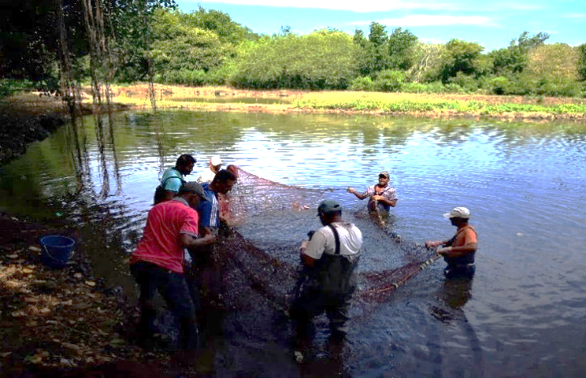
Figure 10 - Seining operation

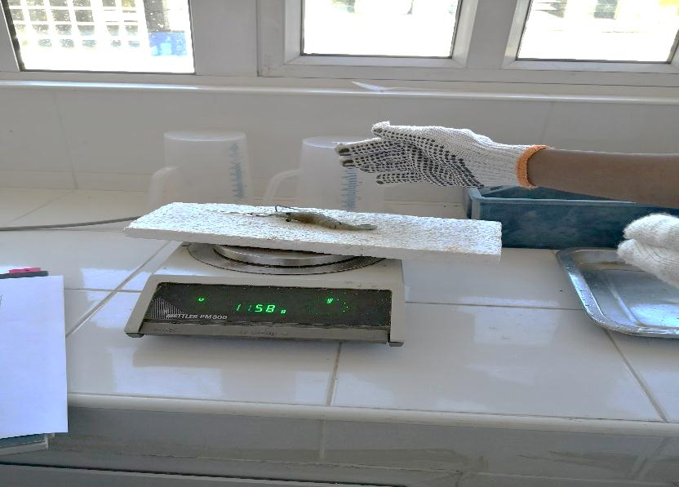
Figure 11 - Sampling of freshwater prawn
Culture as well as breeding techniques of two commercially viable freshwater ornamental fish species; (Fighter fish - Betta spendens var.) and Cherry barb (Puntius titteya) were undertaken by the Aquaculture Division. Some 300 fingerlings of fighter fish and 30 fingerlings of Cherry barb were successfully produced.

Technical assistance and support were provided to 127 persons who called at the Aquaculture Division for information on aquaculture projects.

Competent Authority Seafood (CASF)
Statistics for the period from July 2018 to June 2019 are as per Table 2 below.
1 | Number of EU Export Health Certificates issued by the CASF | 3,050
2 | Number of non-EU Export Health Certificates issued by the CASF | 2,059
3 | Total Number of Export Health Certificates issued by the CASF | 5,109
4 | Number of official audits carried out by the CASF | 44
5 | Number of registered Fish Business Operators | 31
6 | Number of newly registered Fish Business Operators | 1
7 | Number of EU-approved establishments | 18
8 | Total Revenue collected | Rs5,214,000

Table 2- Statistics from Competent Authority Seafood

Fisheries Protection Service
397 cases relating to fisheries were reported during the period July 2018 to June 2019 as shown in Table 3, of which 173 concerned illegal net fishing, resulting in seizure of
5,319.09 metres of illegal nets.
43 cases were prosecuted during the FY 2018-2019, resulting in the collection of
Rs 79,500 as fine.

Month | Illegal Nets  (Units) | Underwater Fishing  (Units) | Undersized Fish  (Units) | Other Cases | Total cases | Net Secured (Metres)
2018
July | 11 | 4 | 0 | 4 | 19 | 429.75
August | 16 | 9 | 2 | 8 | 35 | 888.75
September | 21 | 6 | 0 | 4 | 31 | 768.18
October | 18 | 18 | 0 | 6 | 42 | 320.72
November | 13 | 18 | 1 | 6 | 38 | 355.12
December | 8 | 13 | 0 | 3 | 24 | 286.36
2019
January | 16 | 23 | 3 | 7 | 49 | 581.00
February | 19 | 12 | 0 | 5 | 36 | 228.25
March | 15 | 14 | 1 | 3 | 33 | 512.35
April | 12 | 12 | 1 | 6 | 31 | 233.65
May | 14 | 16 | 0 | 4 | 34 | 487.11
June | 10 | 11 | 0 | 4 | 25 | 227.85
Total | 173 | 156 | 8 | 60 | 397 | 5,319.09
Table 3 - Fine inflicted in breach of Fisheries Act
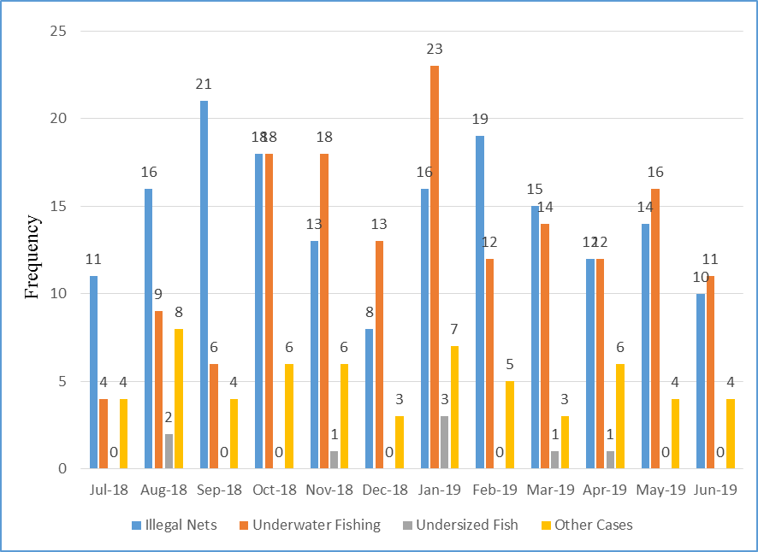
Figure 12 - Statistics from Fisheries Protection Service
2018 |  |  | 2019
Month | No. of Cases | Fine  (Rs) | Month | No. of Cases | Fine  (Rs)
July | 6 | 7,000 | January | 1 | 1,000
August | 7 | 14,000 | February | 4 | 21,000
September | 2 | 2,700 | March | 6 | 5,500
October | 3 | 6,500 | April | 1 | 500
November | 5 | 5,000 | May | 3 | 6,500
December | 2 | 2,800 | June | 3 | 7,000
Total | 25 | 38,000 | Total | 18 | 41,500
Table 4 – Statistics on number of cases and amount collected as fine

Fisheries Training and Extension Centre (FiTEC)
A multipurpose support vessel, 18.6 m in length amounting to Rs57M was under construction in Australia. The vessel was expected to be delivered at Port Louis in September 2019.

Training in ‘Fish Handling, Preservation and Marketing’ was provided to 73 fishmongers.

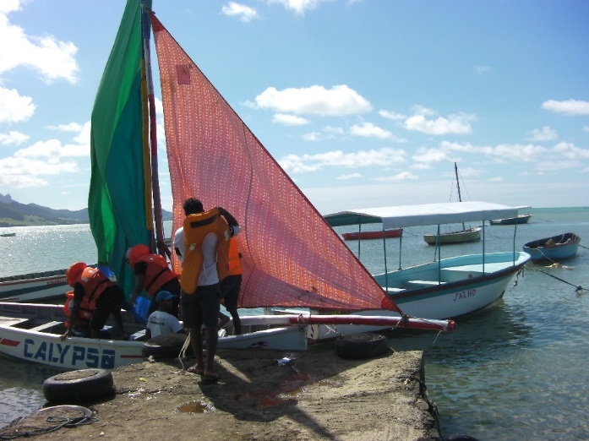
Figure 13 - Initiating trainee fishers to use sail

Training in ‘General Course for Fishers’ was provided to 70 fishers.
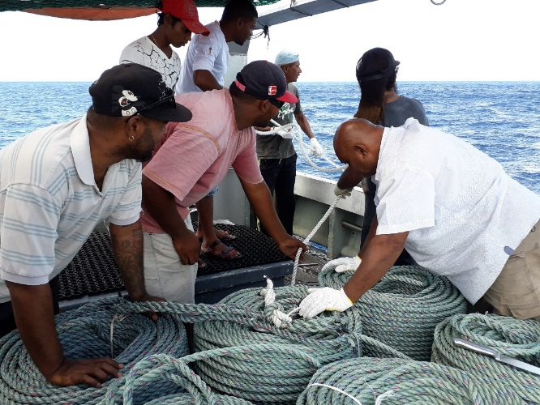
Figure 14 - Trainee fishers participating in deployment

29 sea trips were carried out for the
re-setting, verification and maintenance of FADs and practical training (General Course for Fishers) around the island.
Three FADs were replaced and 15 FADs were kept active as at June 2019.
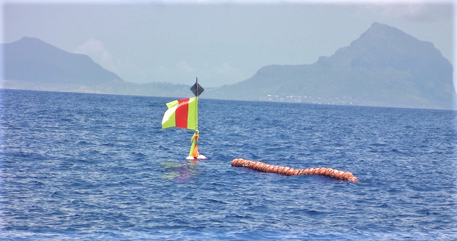
Figure 15 - FAD deployed at sea to attract migratory pelagic fish

Laboratories Division
The Mauritius Accreditation Service (MAURITAS) maintained accreditation to the
MS ISO/IEC:17025 Standard for the Marine Chemistry Laboratory and the Marine Microbiology Laboratory following its annual surveillance visit in March 2019.

The Marine Chemistry, the Marine Microbiology and the Fish Toxicity Laboratories successfully participated in the International Proficiency Testing Programme for quality assurance and the technical competence of its test results.

352 seawater samples were collected from the 26 permanent representative sites, namely, Bel Ombre, Bambous Virieux, Trou d’Eau Douce, Anse la Raie, Trou aux Biches, Pointe aux Sables, Bain des Dames, Grand Bay, Baie du Tombeau, Harbour, Poudre d’Or, Balaclava, Blue Bay, Belle Mare, Albion, Flic-en-Flac, Palmar, Mon Choisy, Pereybère, Le Morne, Ile aux Benitiers, Bain Boeuf, Ferme Marine de Mahebourg Ltd, Baie du Tombeau Outfall, Montagne Jacquot Outfall and Pointe Moyenne Outfall and 2,464 analyses were conducted for
physico-chemical parameters.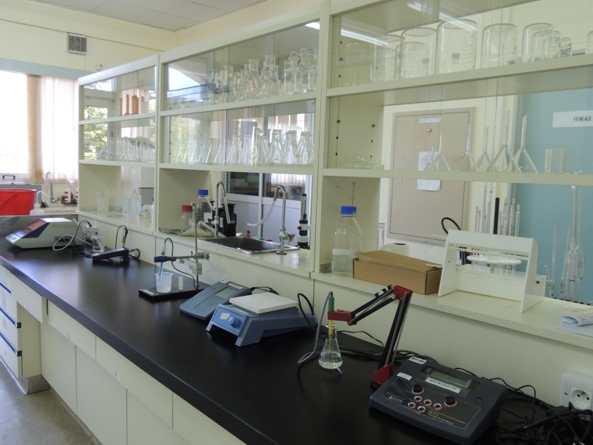
Figure 16 - Marine Chemistry Laboratory at the AFRC
16 seawater samples were collected at eight estuaries and analysed to determine the levels of heavy metals namely, Chromium, Copper, Lead, Arsenic, Mercury and Cadmium.

294 seawater samples were collected from 13 selected public beaches, namely, Flic-en-Flac, Trou aux Biches, Mon Choisy, Blue Bay, Albion, Pointe aux Sables, Grand Baie, Le Goulet, Belle Mare, Pereybère, Baie du Tombeau, Sable Noir and La Cuvette and 1,764 analyses were performed to determine the levels of coliform bacteria.

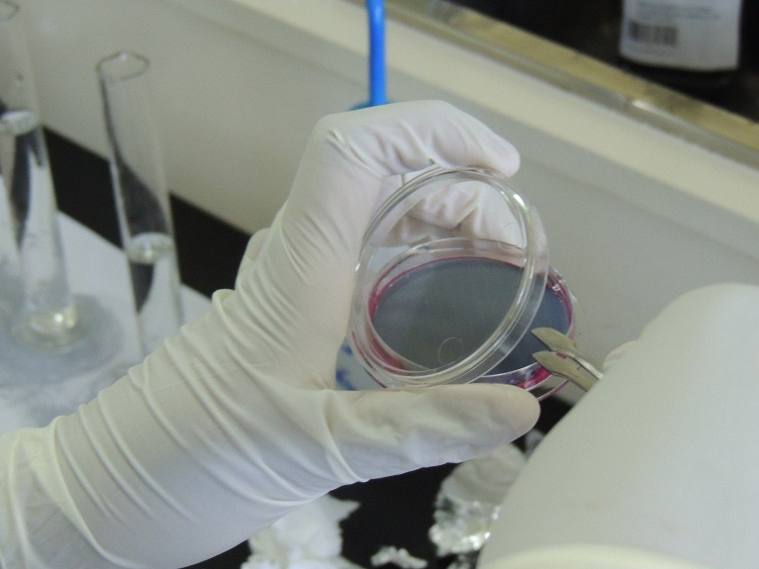
Figure 17 - Membrane Filtration technique for analysis of coliform bacteria

66 macro-algae samples were collected from five representative sites for identification and enumeration of harmful marine microalgae.
Seven fish samples were processed for toxicity tests.
A poster entitled ‘The Temporal, Seasonal and Spatial Distributions of Fish Kills in Mauritius’ was presented at the 11th Scientific Symposium organised by the Western Indian Ocean Marine Science Association (WIOMSA) and the Nairobi Convention at the University of Mauritius in July 2019.

A scientific paper entitled 'Spatial and Seasonal variations of harmful benthic dinoflagellates in the coastal waters of Mauritius' was presented at the International Conference Ocean Engineering 2019 organised by the University of Mauritius in collaboration with India Institute of Technology, Madras in July 2019.

A baseline study on the levels of Escherichia coli and Enterococci bacteria at six selected public beaches was initiated in January 2019.
27 samples comprising marine biota (fish, algae, shellfish and sea cucumber), sediments and seawater from five sites around Mauritius were analysed for radionuclides at the International Atomic Energy Agency (IAEA) in Monaco during a two-month fellowship from September to November 2018.

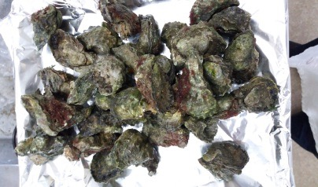
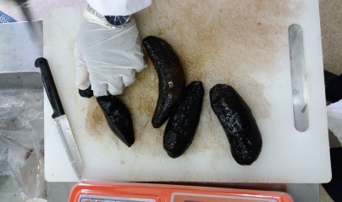
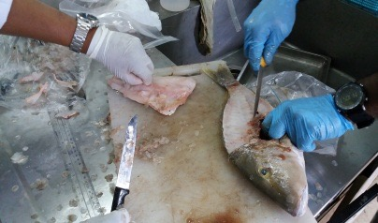
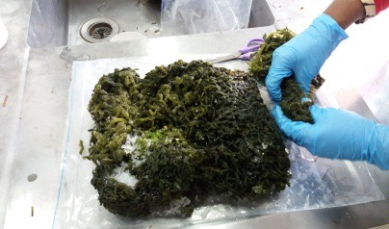
Figure 18 - Pre-treatment of marine biota for radionuclides analysis

Participation in three regional projects (RAF7014, RAF7015 and RAF7017) funded by the IAEA under its Technical Cooperation Program for Africa was on-going since 2016.

An Alpha Spectrometry equipment was received in December 2018 from IAEA under the regional project RAF7015 for analysis of alpha emitting radionuclides in marine environment.

Marine Conservation Division
A second batch of 500 coral fragments were fixed on polypropylene ropes as a trial during the Financial Year 2018-2019 and showed signs of positive growth. Out of the 1,500 coral fragments, about 350 coral fragments that were placed in coral nurseries were transplanted to a degraded area in the Strict Conservation Zone A of the Blue Bay Marine Park (BBMP) during the Financial Year 2018-2019 and were also showing constant growth. The remaining coral colonies were used as donor colonies to
re-establish the coral nurseries.
317 permits were issued/ renewed for permissible activities in Marine Protected Areas amounting to Rs2,522,100.
35 Environmental Impact Assessment Reports, amongst which 20 coastal, were processed and views of the Ministry submitted to the Department of Environment.
19 applications for Ramsar clearance were processed and views of the Ministry were submitted to the National Ramsar Committee.
92% of ground-truthing surveys of specific areas of mangroves around the coastal belt of the Republic of Mauritius were completed. The 11 remaining sites would be surveyed by consultants hired under Component one of the UNDP/GEF/GoM project "Mainstreaming biodiversity within the management of the coastal zone of Mauritius".
The long-term monitoring of coral reefs in the Blue Bay Marine Park (five stations) and the Balaclava Marine Park (five stations) were completed.
28 ad-hoc ecological surveys were carried out in respect of coastal development projects.

Marine Resources Division
In the Banks Fishery, a total of 556.8 tonnes of frozen fish was landed by three vessels. Seven logbooks were verified and three sampling exercises were carried out for Lethrinus mahsena (frozen) involving 1,084 specimens.
In the Saint Brandon Inshore Fishery, a total of 241.7 tonnes of fish was landed by 16 vessels. Seven sampling exercises were carried out involving 923 specimens.
In the Chilled Fish Fishery, a total of 480.2 tonnes of fish was landed by 22 vessels. Ten sampling exercises were carried out involving 1,496 specimens.
In the Deepwater Snapper/Grouper Fishery, a total of 465.4 tonnes of fish was landed by 15 vessels. Three sampling exercises were carried out for involving 522 specimens.
A total of 331 logbooks were verified from the Saint Brandon Inshore Fishery, Chilled Fish Fishery and Deepwater Snapper/Grouper Fishery.
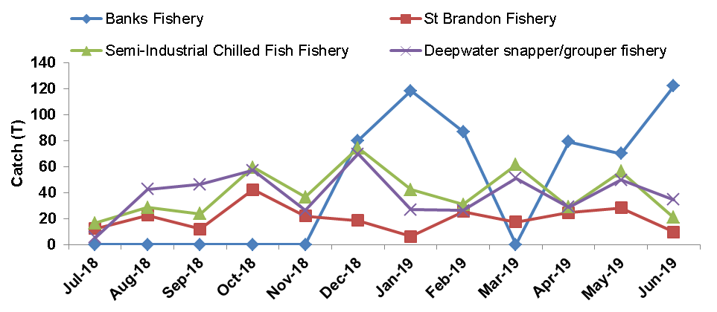
Figure 19 - Monthly catch by fishery - Offshore demersal fishery project

In the Coastal Fishery, some 25 Fish Landing Stations were randomly selected every month from the three established geographical strata, namely North, East and West regions around Mauritius and 1,697 landings were monitored during the
FY 2018-2019.
Octopus Fishery
Octopus fishery represents an important resource for coastal communities. It is an economic activity, which contributes to the economic gain of fishers and ensures food security. Octopus fishery represents about 7% of artisanal annual catch in Mauritius. It is a highly priced commodity and its preservation and sustainable exploitation are of utmost importance.
The species of octopus commonly fished in Mauritius are mainly Octopus cyanea and Octopus vulgaris. Octopus cyanea is native to Mauritius and is the most common species of octopus fished in the Indian Ocean waters.

Exhibits received at the Coastal Fishery Unit

A total of 2,621 units and 6.35 kg of various marine species received from 163 occurrences in respect of various offences under the Fisheries and Marine Resources Act 2007 were examined, identified and reported accordingly by the Coastal Fishery Unit.

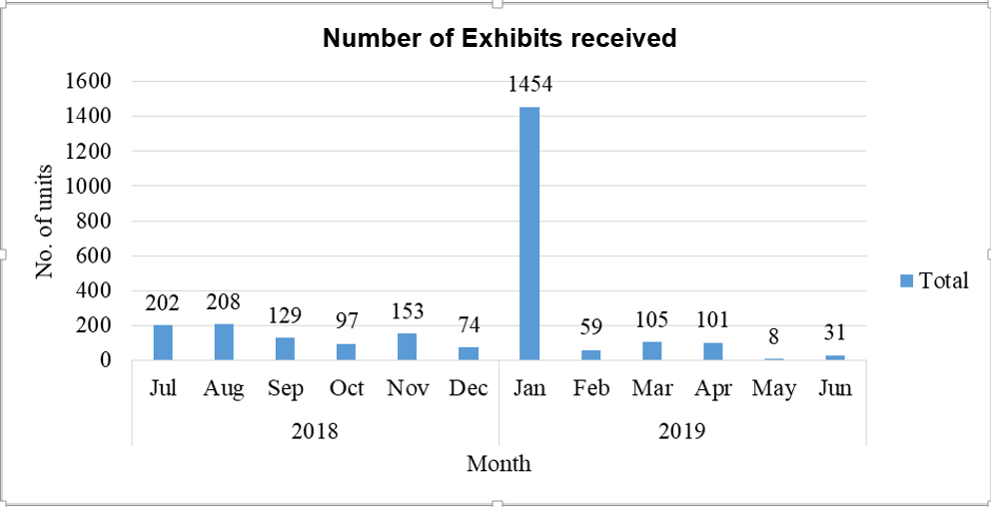
Figure 20 - No. of Exhibits examined from July 2018-June 2019

Octopus Sensitisation Campaign 2018
The octopus sensitisation campaign on the importance of the closure of the octopus fishing was carried out at eight different regions around the island, namely, Bambous Virieux, Grand Gaube, Tamarin, Le Morne, Mahebourg, Riambel, Trou D’eau Douce and Grand Bay to sensitise fishers, fishmongers and the public at large.
The sensitisation campaign emphasised the importance of protecting young octopuses, enabling them to grow; to spawn; to sustain the species in the lagoon and to avoid illegal fishing. The daily catch per fisher prior to octopus closure in 2018 was estimated at two kg whereas the daily catch after reopening of octopus fishery was estimated at seven kg, indicating that the catch had tripled after reopening of octopus closure in 2018. A price was awarded to the best octopus caught.
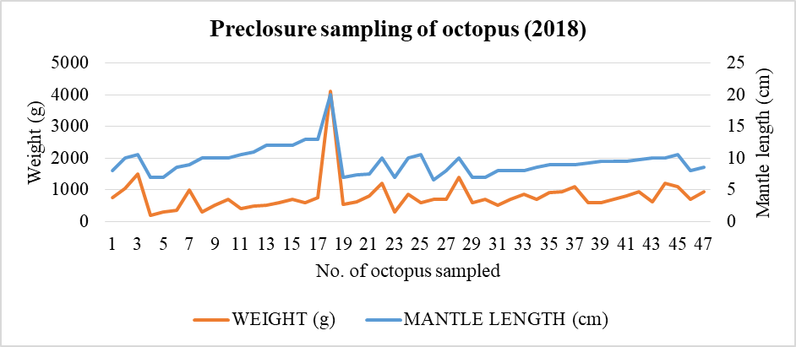
Figure 21 - Sampling of Octopuses before closure of Octopus Fishery (2018)

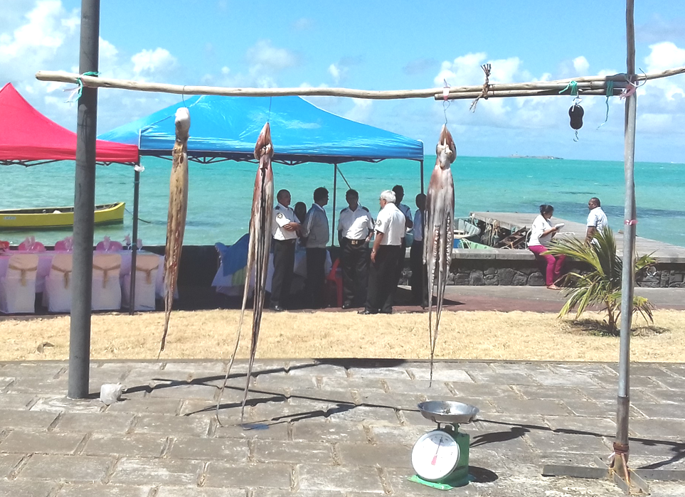

Figure 22 - Best Octopus catch on re-opening of Octopus Fishery (2018)

Pelagic Fishery
Regarding the Pelagic Fishery, the Mauritian fleet consisted of three purse seiners and 11 semi-industrial tuna longliners. The third purse seiner joined the fishery in January 2019.

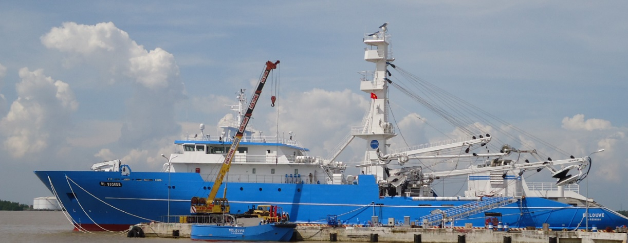
Figure 23 - The third purse seiner “Belouve” joined the fishery in January 2019
The three purse seiners undertook 30 fishing campaigns. The data collected from the fishing logbooks were verified, processed and data base updated. A total of 22,670 tonnes of tuna were caught. Morphometric sampling programmes were carried out during unloading at Port Louis on 2,611 tuna specimen comprising yellowfin, skipjack and bigeye. Most of the catch were unloaded in Seychelles.

The eleven Mauritius-flagged longliners operated both inside and outside the EEZ. Data collected from 156 fishing logbooks were verified, processed and data base updated. Their total catch amounted to 762 tonnes. The main catches consisted of swordfish and tuna species. Sampling exercises were carried out in port and different length measurements were taken from a total of 1,175 swordfish and tuna species.
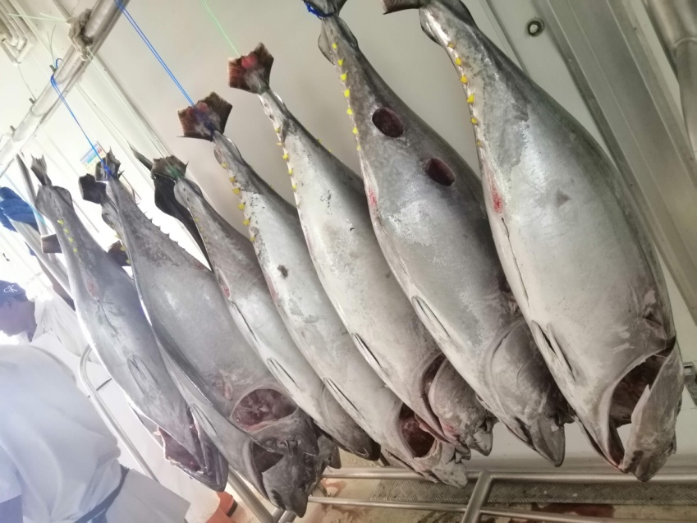
Figure 24 - Tuna being unloaded by small longliners

The foreign-flagged longliners (mostly Asian) licensed to fish in the EEZ of Mauritius carried out 265 trips. Data from the fishing logbooks were verified, processed and data base updated. A total catch of 10,460 tonnes, mainly albacore tuna was recorded. 900 albacore were sampled for length frequency during unloading of the fishing vessels.
Seven Conservation and Management measures were adopted at the 23rd session of the Indian Ocean Tuna Commission (IOTC) in June 2019:
- Resolution 19/01 On an interim plan for rebuilding the Indian Ocean yellowfin tuna stock in the IOTC Area of competence.
- Resolution 19/02 Procedures on a fish aggregating devices (FADs) management plan.
- Resolution 19/03 On the conservation of mobulid species caught in association with fisheries in the IOTC Area of Competence.
- Resolution 19/04 Concerning the IOTC Record of Vessels Authorised to operate in the IOTC Area of Competence.
- Resolution 19/05 On a ban on discards of bigeye tuna, skipjack tuna, yellowfin tuna, and non-targeted species caught by purse seine vessels in the IOTC Area of Competence.
- Resolution 19/06 On establishing a programme for transhipment by large-scale fishing vessels.
- Resolution 19/07 On vessel chartering in the IOTC Area of Competence.

Marine Science Division
12 underwater surveys were carried out at eight sites, namely, Le Goulet, Baie du Tombeau, Anse la Raie, Poudre D’Or, Belle Mare, Trou d’eau Douce, Bel Ombre, Ile aux Benitiers around Mauritius in the shore reef, back reef and fore reef under the long-term coral reef monitoring programme.
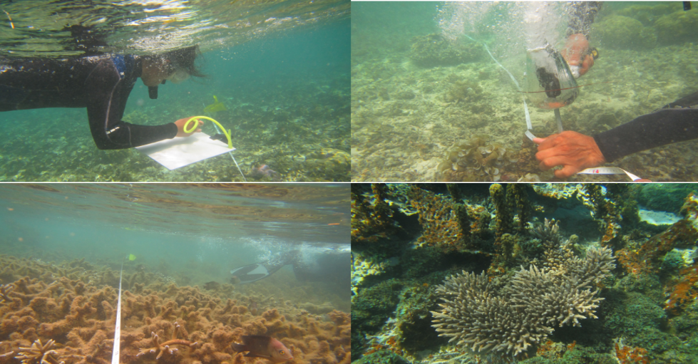
Figure 25 - Coral Reef Monitoring 2018-2019

Two crown of thorns population surveys were carried out in collaboration with Reef Conservation and Wise Ocean at two reef areas namely Eau Bleue and Trou aux Biches in Mauritius. Remedial actions were being initiated by Reef Conservation.
A Protocol/Action Plan for control of crown of thorns population outbreak had been prepared.
15 nurseries had been added in the Blue Bay Marine Park, giving a total of 30 nurseries present in the Marine Park. The 30 nurseries were accommodating 2,880 coral fragments for future transplantation.
The NGO Eco-Sud was allocated a permit to construct one coral farm, on a pilot basis, at Pointe D’Esny using the rope method and to establish a Voluntary Conservation Zone in the same area, to protect and conserve a large seagrass bed. The project had been monitored.
A training workshop on the monitoring and ground truthing of seagrass were carried out in Mauritius by experts from Reunion island.
Three Swimming Zone demarcation surveys and one boat passage demarcation surveys were carried out to assist the Tourism Authority and the Ministry of Tourism in their sea-based activities projects.
Five underwater surveys were carried out around Mauritius for the demarcation of a suitable area to operate firework displays at sea on 31 December 2018. The Ministry had entertained 48 requests for fireworks display during the FY 2018-2019.
The Terms of Reference of the National Coral Reef Network Committee and an Action Plan had been drafted.
A training workshop was carried out with the University of Mauritius students on marine turtle conservation.
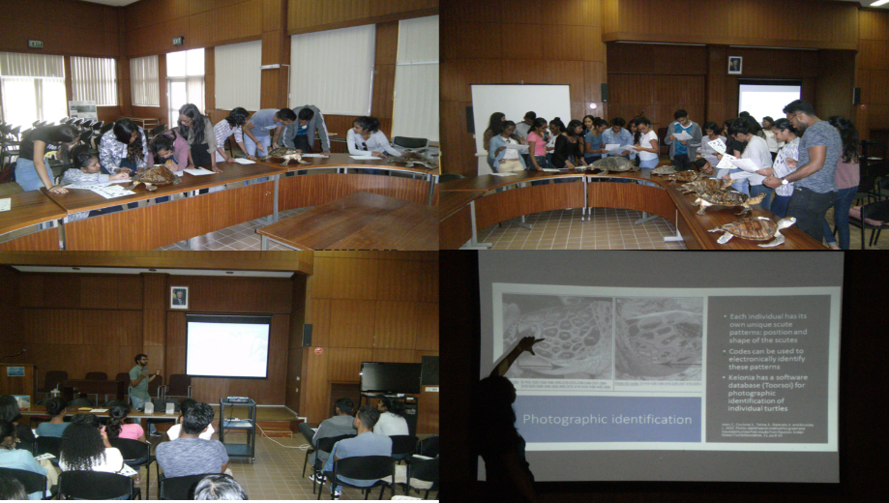
Figure 26- Hands-on Training on Marine turtle to UOM Students
Three turtle nesting surveys were carried out on Flat Island, where six potential marine turtle nests were recorded.
An Inter-Ministerial Committee was set up to finalise the draft Action Plan on the disposal of marine turtle carcasses.
Three injured marine turtles were rescued, treated, rehabilitated and released. As at 30 June 2019, one turtle was still under observation. Five cases of dead turtles due to boat strikes were attended to and disposed of as per the protocol.
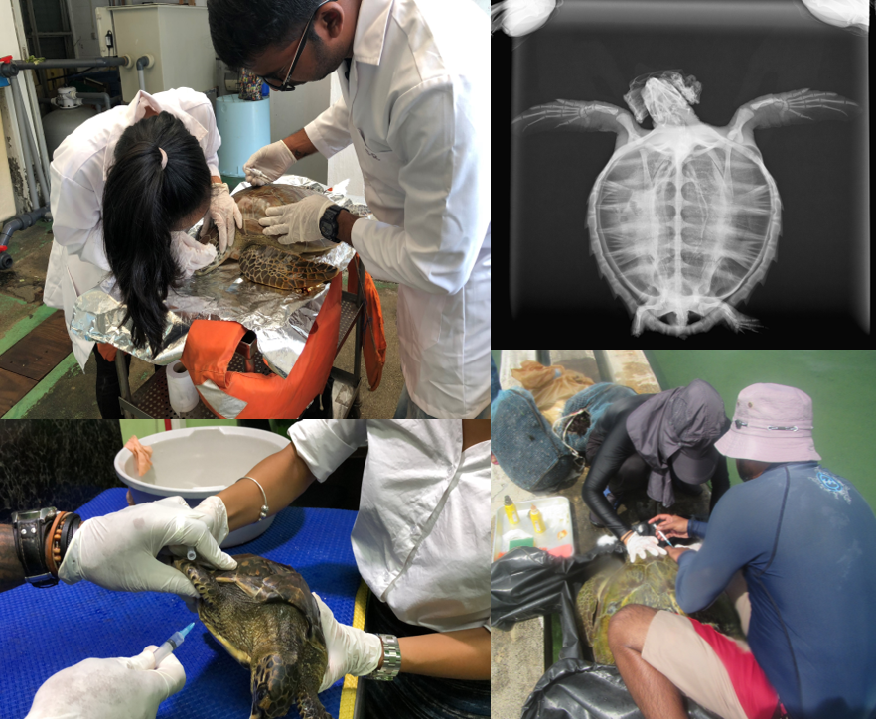
Figure 27 – Marine Turtle treatment at AFRC
A collaborative project, namely, “Restoring marine ecosystem services by rehabilitating coral reefs to meet a changing climate future” amounting to USD10M, between Mauritius and Seychelles had been approved by the Adaptation Fund Board. A Memorandum of Understanding was prepared in that respect.
600 mangroves propagules were planted at Pointe D’Esny.
Ten sites visits were carried out in connection with Coastal Development projects and views were submitted accordingly.

Monitoring, Control and Surveillance/ Vessel Monitoring System/ Port State Control/ Import/ Export Division
Monitoring, Control and Surveillance/ Vessel Monitoring System/ Port State Control Unit
- Two observers participated in the Observer Programme on board Purse Seiners FV Belle Rive and FV Belle Isle involving a coverage of 139 days at sea
- Two observers participated in the Regional Observer Scheme on board two Mauritian Longliners (Félicité Mackenzie and FV Clairabelle Jayde) for four trips involving a coverage of 57 days at sea
- 390 departure clearances for local semi-industrial fishing boats/ vessels were issued
- 1,425 Processing Statements were validated and endorsed
- 630 Catch Certificates were validated and endorsed
- 25 Swordfish Statistical Documents were verified, validated and endorsed
- 217 Big Eye Statistical Documents were validated and endorsed for Mauritian flagged vessels
- 186 Big Eye Re-Export Certificates were validated and endorsed for Foreign flagged vessels
- 390 callings, boarding and inspection of local fishing vessels were recorded
- 946 callings, boarding and inspection of foreign fishing vessels were recorded
- 13 callings of Patagonian Toothfish vessels were recorded
- 2,291 MT of Patagonian Toothfish were transhipped
- Ten callings of Trawlers were recorded
Import and Export Unit
- 174 individuals/companies were registered as importers for the import of fish and fish products
- Each importer paid a registration licence fee of Rs25,000 to the Mauritius Revenue Authority, which amounted to Rs4,350,000 for the 174 registered importers
- A total of 3,926 landing permits were issued during FY 2018-2019
- 144,958 tons of tuna were imported for processing and 18,980 tons of fish and fish products were imported for direct consumption
- A total of 120,753.7 tonnes of fish and fish products (salted snoek, frozen fish, chilled fish, canned fish, tuna in jars, tuna in pouch, frozen precooked tuna, frozen processed tuna, fish meal, fish oil) were exported

The details on the import of fish and fish products for the FY 2018-2019 are presented in Table 5 and Table 6.

TYPE | PRODUCT | Jul- Dec 2018  (Tonnes) | Jan-June 2019  (Tonnes) | Total  (Tonnes)
Chilled | Fish | 69 | 57 | 126
 | Crustacean | 9 | 5 | 14
 | Cephalopod | 1 | 1 | 2
 | Shell Fish | 14 | 4 | 18
Frozen | Fish | 3,033 | 2,635 | 5,668
 | By Catch | 1,384 | 949 | 2,333
 | Crustacean | 1,107 | 819 | 1,926
 | Cephalopod | 720 | 726 | 1,446
 | Shell Fish | 36 | 52 | 88
Frozen Prepared Products | Fish | 647 | 475 | 1,122
 | Cephalopod | 16 | 4 | 21
 | Crustacean | 95 | 66 | 161
Canned Products | Fish | 1,935 | 3,912 | 5,847
 | Crustacean | 0 | 1 | 1
Dry | Fish | 52 | 57 | 109
 | Crustacean | 33 | 60 | 93
 | Cephalopod | 1 | 3 | 4
Frozen For Processing | Barracouta | 442 |  | 442
Frozen Tuna For Processing | Tuna/Processing | 51,782 | 93,176 | 144,958
Frozen Tuna | Tuna/Processing/ Export | 2,772 | 9,665 | 12,437
Dry | Fish Feed | 2,362 | 5,900 | 8,262
Live (Units) | Ornamental Fish | 449,284 | 301,091 | 750,375
 | Fish For Culture | 712,000 | 1,800,000 | 2,512,000
Table 5 - Import of fish and fish products for FY 2018-2019

PRODUCTS | JULY- DECEMBER 2018 (TONNES) | JANUARY - JUNE 2019 (TONNES) | TOTAL  (TONNES)
Salted snoek | 30.7 | 31.1 | 61.8
Chilled fish | 19.3 | 15.4 | 34.7
Chilled fish from Aquaculture | 823 | 816 | 1,639
Fish meal | 10,301 | 6,508 | 16,809
Fish oil | 690 | 922 | 1,612
Frozen/precooked tuna | 7,780 | 5,275 | 13,055
Frozen processed tuna | 2,181 | 1,472 | 3,653
Frozen fish | 29,664 | 2,139 | 31,803
Tuna in pouch | 7,479 | 4,444 | 11,923
Tuna in jars | 258.6 | 215.6 | 474.2
Canned tuna | 18,200 | 21,489 | 39,689
PRODUCTS | JULY- DECEMBER 2018 (UNITS) | JANUARY - JUNE 2019 (UNITS) | TOTAL  (UNITS)
Live marine ornamental fish | 3,397 | 2,337 | 5,734
Live freshwater ornamental fish | 827 | 1,069 | 1,896
Export Authorisation | 2,559 | 2,688 | 5,247
Table 6 - Export of fish and fish products for FY 2018-2019

Planning and Licensing Division
Four bank fishing vessels had actively operated on the Saya de Malha and Nazareth Banks. Two licences were issued, representing an amount of USD1,000 for foreign flagged vessel and Rs1,000 for local vessels.
Nine new fishing boats joined the demersal chilled fish fishery. A total of 48 licences were issued, representing an amount of Rs48,000.
Three purse seiners and one supply vessel were active in the pelagic fishery. Four licences were issued, generating an amount of USD95,000.
A total of 206 Foreign Fishing Licences/Extension Licences were issued in respect of longliners outside Fishing Agreement of nationalities of Republic of Korea, Malaysia, Sultanate of Oman and People’s Republic of China, which amounted to USD1,662,000.
Six licences/Extension licences were issued in respect of purse seiners/supply vessel of nationality of Republic of Korea, representing a total licence fee of USD15,000.
Under the Fishing Agreement between the Republic of Mauritius and the Republic of Seychelles, a total of 24 licences were issued, generating an amount of USD442,000 as licence fees.
Under the Fishing Agreement between the Republic of Mauritius and the European Union, a total of 56 licences were issued to purse seiners/longliners and the total licence fees amounted to EUR298,050.
Under the Fishing Agreement between the Republic of Mauritius and the Federation of Japan Tuna Fisheries Cooperative Association (JTFCA) for Fishing in Mauritian waters, a total of four licences were issued to longliners and the total licence fee amounted to USD64,000.
A total of 12 Letters of Intent were issued to acquire vessels – one for Bank Fishery; eight for Semi-industrial Chilled Fish Fishery; and three for Advance Coastal Fishery. Ten extensions of Letter of Intent were issued – nine for Semi-industrial Chilled Fish Fishery; and one for Advance Coastal Fishery.

Shipping Division
Mauritius became the 15th signatory State to the Jeddah Amendment to the Djibouti Code of Conduct (DCoC) on 26 July 2018, following Cabinet approval.

With a view to implementing amendments to Regulations 2 of the International Convention for the Safety of Life at Sea (SOLAS) for Verification of Gross Mass (VGM) of packed containers, a system had been developed for the verification of gross mass of packed containers through the entry into operation of the Merchant Shipping (Weight Verification of Containers). The regulations entered into force on
01 October 2018.

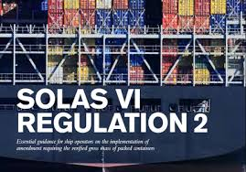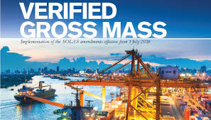
Figure 28 - Verification of Gross Mass

The Mauritius Long Range Identification and Tracking of Ships (LRIT) National Data Centre had successfully passed the International Mobile Satellite Organization (IMSO) audit conducted on 28 January 2019 based on its performance, which was in line with the required standards.

The Report of the Port Biological Baseline Survey (PBBS) was submitted to Port Mathurin, Rodrigues, by the Mauritius Oceanography Institute on 17 October 2018 subject to a prior agreement with the Mauritius Oceanography Institute to detect the presence of any introduced species.

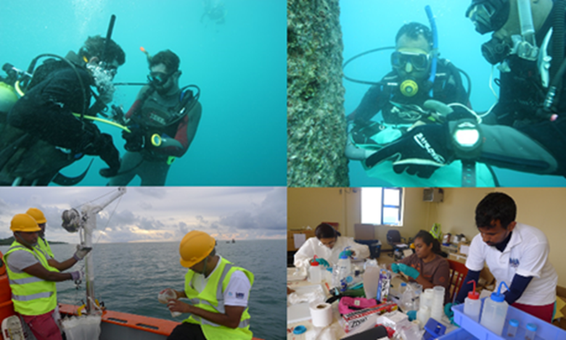
Figure 29 - Collection and Analysis of Samples

The International Maritime Organization (IMO) in collaboration with the United Nations Development Programme (UNDP) and the Global Environment Facility (GEF) had initiated the GEF-UNDP-IMO GloFouling Project under the GloBallast Programme to protect marine ecosystems from the negative effects of invasive aquatic species.

The project was launched in December 2018 to drive actions to implement the IMO Guidelines for the control and management of ships' biofouling and would span for a period of five years (mid-2018 to 2023)

Mauritius had been selected by the IMO as one of the twelve Lead Partnering Countries (LPC) of the GloFouling project.

Pursuant to section 228 of the Merchant Shipping Act 2007, new Merchant Shipping Regulations that had been made by the Honourable Minister of Ocean Economy, Marine Resources, Fisheries and Shipping were enforced. These Regulations were available at the Ministry’s website and might be downloaded from http://blueconomy.govmu.org

The Acropolis Shipping Agency Ltd, a private sector Maritime Training Institution was temporarily approved by the Ministry to conduct STCW Courses. During the Financial Year 2018-2019, the Acropolis Shipping Agency Ltd had trained 552 students.
S/N | SERVICES | QUANTITY  (UNITS)
1. | Endorsement Certificates Issued | 163
2. | Attestation Certificates Issued | 55
3. | Certificates of Competency/Proficiency Issued | 11
4. | Ship's Cook Certificates issued | 18
5. | Port Clearances Issued | 2,989
6. | Discharge Books Issued | 1,072
7. | New Vessels registered under the Mauritian Flag  (As at 30 June 2019, there were 134 registered vessels under the Mauritian Flag) | 4
8. | Number of Surveys and Inspections | 61

Table 7- Statistics from Shipping Division for period July 2018 to June 2019

Mauritius Maritime Training Academy
The MMTA had provided STCW training courses to 977 candidates during the Financial Year 2018-2019, giving them the opportunity of finding employment in the cruise sector.
The courses included Basic Safety Training, Crowd Management, Crisis Management, Proficiency Security Awareness, Designated Security Duties and Engine Watch.
TRAINING COURSE | NUMBER OF MALE CANDIDATES | NUMBER OF FEMALE  CANDIDATES | TOTAL
Basic Safety; Crowd Management; Crisis Management; and Proficiency Security Awareness | 790 | 112 | 902
Designated Security Duties | 8 | 9 | 17
Engine Watch | 1 | 0 | 1
Oil Tanker | 24 | 1 | 25
General Purpose Rating | 31 | 1 | 32
TOTAL | 854 | 123 | 977
Table 8 - Statistics for Financial Year 2018-2019

MS ISO 9001:2015 Certification

The MMTA was MS ISO 9001:2015 certified on 31 March 2019 and the ISO Certificate was valid until 20 September 2021 subject to relevant terms and conditions being met.

Basic Training Course on Oil Tanker Cargo Operations

Two batches of the Basic Training Course on Oil Tanker Cargo Operations were conducted from 10 to 17 September 2018 and from 15 to 19 April 2019. Thirty-six (36) trainees successfully completed the course.
The practical training part for the above course was provided, free of charge, in collaboration with Taylor Smith Ltd.

General Purpose (GP) Ratings Course

The General Purpose (GP) Ratings Course was organised in collaboration with the MMTA, the Mauritius Ports Authority (MPA), the Mauritius Shipping Corporation Limited (MSCL) and the Human Resource Development Council (HRDC) under the National Skill Development Programme (NSDP). Thirty-two (32) trainees followed the GP Ratings course from 15 November 2018 to 22 April 2019.

Budget Measures
Budget  paragraph | Budget Measures | Status as at 30 June 2019
75 (i) | Setting up an Ocean Economy Unit with the responsibility of preparing a National Ocean Policy Paper. | Clarification from the Attorney- General’s Office sought for the filling in of the post of Head of Ocean Economy unit.
75 (ii) | Merging of the Mauritius Oceanography Institute and the Albion Fisheries Research Centre into one single institution. | After having lengthily discussed on the issue, it was decided to go for an Operational Merging only and to maintain the existing locations of the Mauritius Oceanography Institute and the Albion Fisheries Research Centre.
75 (iii) | Developing of an Ocean Observatory e-platform to support the Marine Spatial Planning Initiative of Mauritius. | This had been dealt with by the Ministry of Defence and Rodrigues.
75 (iv) | Conducting of a geotechnical study in the continental shelf management area of the Mascarene region to explore its potential. | This had been dealt with by the Ministry of Defence and Rodrigues.
75 (v) | Introduction of a Group Life Insurance Scheme for Registered Fishermen to cover any accidents and losses at sea. | Tendering exercise was carried out. However, same was not successful.
75 (vi) | Allowing foreign industrial fishing companies to fish in our shallow water banks to increase the availability of fish locally and in line with our import strategy. | The project was not implemented due to representations made by fish operators.
75 (vii) | Providing all registered fishermen with a free icebox. | Ice boxes were delivered to registered fishers in May 2019.

Table 9 - Budget Measures for FY 2018-2019

Key Actions
Key Action | Key  Performance  Indicator | Target  2018-2019 | Achievement as at 30  June 2019
Increase fish production through small scale aquaculture | Tonnes of fish harvested through cage culture | 30 | 0.5  (off-track due to the absence of proper maintenance of the floating net cages)
Coral farming for rehabilitation of degraded coral reefs | Number of degraded sites rehabilitated | 1 | 1
Ensure compliance of shipping vessels with national and international maritime standards | Number of vessels registered under Mauritian Flag audited | 6 | 12  (audited locally)
Increasing the number of candidates trained in the Maritime sector | Number of candidates trained at the Mauritius Maritime Training Academy | 1,300 | 977  (Demand-driven training)

Table 10 - Key Actions for FY 2018-2019

Events
Workshop on International Maritime Organisation (IMO) Member State Audit Scheme (IMSAS) Audit of Mauritius
In view of familiarising and preparing stakeholders concerned for the IMSAS Audit, a one-day Inception Workshop on IMSAS Audit of Mauritius was conducted by the Ministry on 08 May 2019 at Balaclava. The main objective of the audit was to verify the following:
- To what extent a Member State met its obligations as Flag, Port and Coastal State
- The effectiveness of the implementation of the mandatory instruments
- The degree of compliance of Mauritius with the Code for the Implementation of mandatory IMO instruments
- How effectively the Shipping Division and other stakeholders concerned administer and implement those relevant mandatory IMO instruments that would be covered by the IMSAS audit

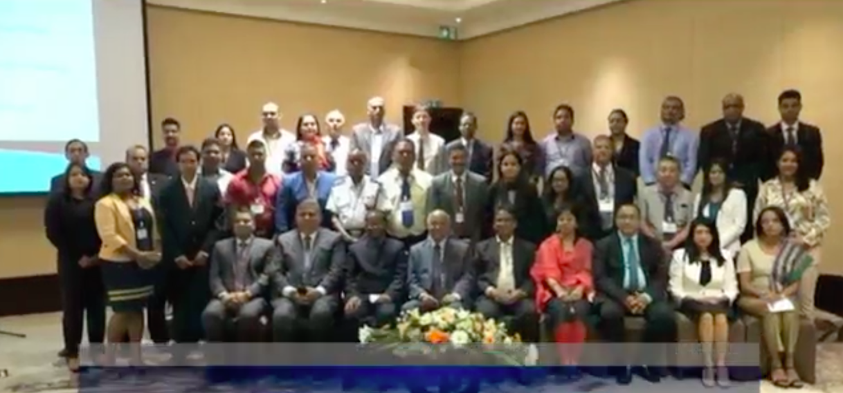

Figure 30 - Guests and Participants at the Opening Ceremony

Celebration for “Day of the Seafarer”

In 2010, the International Maritime Organization (IMO), designated the 25th of June as the Day of the Seafarer as a way to recognize that almost everything that we use in our daily lives is directly or indirectly related to sea transport. The purpose of the Day of the Seafarer is to give recognition to the contribution of the seafarers in the world economy and the civil society, and for the risks that seafarers bear while on duty.

The theme for the Day of the Seafarer for the year 2019 was “I Am On Board with gender equality”, with emphasis on the importance and value of women within the professional ranks.

To mark the event, an official ceremony including a cultural show was organised by the Ministry on 04 July 2019, at the Mauritius Maritime Training Academy (MMTA).

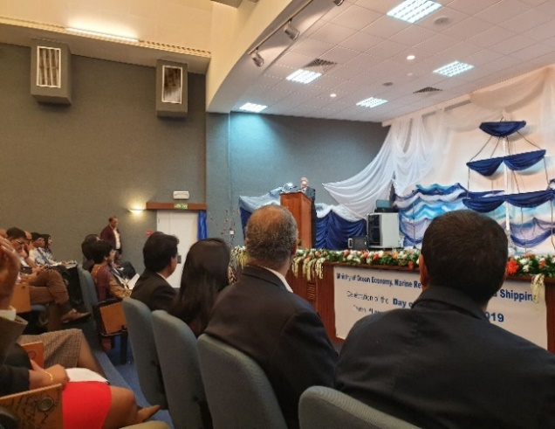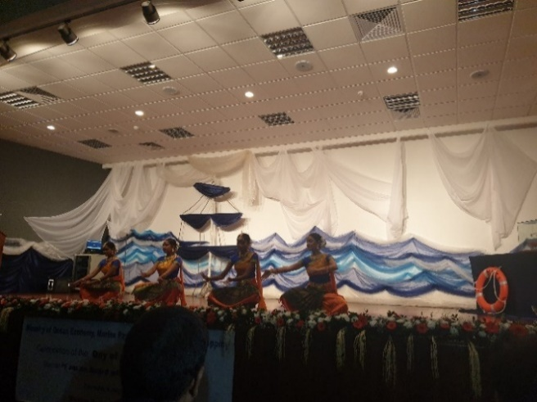
Figure 31 - “Day of the Seafarer” celebrated at MMTA on 04 July 2019

World Ocean Day 2019
The World Ocean Day is celebrated on the 8th of June every year. The following activities were organised by the Ministry from 27 May to 8 June 2019 to commemorate the World Ocean Day 2019 under the theme “Gender and Oceans”, for raising awareness and visibility:
- Launching of “Ocean Carbonate Chemistry Observatory” at MOI on
8 June 2019 by Hon. Premdut KOONJOO, Minister of Ocean Economy, Marine Resources, Fisheries and Shipping
- Quiz Competition on Radio One and Radio Plus Ltd for period from
03 to 07 June 2019
- Sensitisation campaigns in Glass bottom boats at Blue Bay Public Beach and Trou aux Biches Public Beach

Geographic Information Systems (GIS) National Training Workshop

- A training workshop on Geographic Information Systems (GIS) was organised from 14 to 18 January 2019 at the MOI
- The application of GIS with conceptual and practical sessions for the analysis of spatial information using the ESRI ArcGIS suite of applications were introduced
- Basic introduction to GIS including spatial data structures and sources, spatial tools, spatial data display and query, map generation, and basic spatial analysis using ArcGIS software were provided

Implementation Plan – Director of Audit Comments
for FY 2018-2019
ISSUES  (REPORT  REF) | ISSUES | STATUS AS AT JUNE 2019
17.1 | Development of a National Ocean Policy  As part of its Vision 2030, Government placed considerable importance on the development of an  “Ocean Economy”.  On 26 June 2015, Government gave its approval for the setting up, administratively, of the National Ocean Council (NOC). The terms of the reference of the National Ocean Council was among others:  - to ensure the formulation of National Ocean Policy paper that will include the creation of a unified regulatory framework and a National  Ocean Authority. | - Procedures had been initiated with the African Development Bank for the provision of the services of a Consultant to draft the National Ocean Policy. However, due to financial difficulties, this could not be implemented under the assistance obtained from the Commonwealth Secretariat.  - The Ocean Bill had to await the publication of the National Ocean Policy  - Negotiation was scheduled to be held with the World Maritime University for drafting of the Bill  - The draft report received from the FAO was being studied by Mauritius Oceanography Institute
17.2 | Aquaculture Project – Floating Net Cages - Rs12 million  No decision was taken as to whether replace the damaged net and to reallocate the cages to other Cooperative Societies, who were more willing to undertake the fish farming project. | - Repair works could not be carried out as no provision was made in the budget  - A senior Adviser on Fisheries Development was recruited on 15 April 2019 to inter alia advise on the project implementation  - A meeting was held on 26 June 2019 with the representatives of Cooperative Societies to discuss on the pilot project on cage culture  - A draft Agreement had been prepared and forwarded to the Attorney-General’s Office, for vetting
17.3 | Loan to Mauritius Shipping Corporation Ltd – Rs107.2 million  The repayment terms of the loan to Mauritius Shipping Corporation Ltd (MSCL) amounting to Rs107.2M had not been re-scheduled and no repayment was made. | - On 30 April 2019, the Ministry was informed by MOFED that the amount of outstanding loans would be converted into Equity, subject to all relevant procedures being followed and appropriate dividend being paid by the MSCL to Government
17.3.1 | Chartering of a Vessel in lieu of Procurement of a New Vessel  Delays in acquisition of a vessel led to approval of Government to finance the chartering of vessel MV ANNA at an initial annual cost of Rs 40 million which during 2017-18 increased to Rs 75 million. | - In fact, there had been no increase in the cost of chartering the vessel MV Anna. The annual cost of chartering was approximately Rs80 million instead of Rs40 million. The amount of Rs40 million paid for the chartering of MV Anna referred to a period of only six months

Table 11- Implementation Plan – Director of Audit Comments 2018-2019

Financial Highlights
- As per the Estimates 2018-2019, the Ministry of Ocean Economy, Marine Resources, Fisheries and Shipping had two votes under its control as follows:
- 20-1 Ocean Economy, Marine Resources and Shipping
- 20-2 Fisheries
Appropriation of funds were made available under the above votes.
- Revenue collected by Departments falling under the aegis of the Ministry, could be classified into the following two broad categories:
- Fees (including licence fees)
- Non-Tax Revenue (including sale of products, course fees and port clearance fees)

Statement of Revenue
The breakdown of the revenue of the Ministry for FY 2018-2019 is as shown in
Table 12 below.
STATEMENT OF REVENUE
SN | REVENUE | 2017-2018  ACTUAL  (RS) | 2018-2019 ESTIMATES (RS) | 2018-2019  ACTUAL (RS)
1 | Fishing Vessel Licence | 63,061,733 | 64,000,000 | 81,540,170
2 | Shipping Fees | 5,022,892 | 5,070,000 | 6,950,621
3 | Fisheries Fees | 11,516,800 | 12,120,000 | 12,355,500
4 | Sales of Products | 37,000 | 35,000 | 436,196
5 | Miscellaneous (Fisheries) | 5,123,705 | 9,000,000 | 8,877,985
6 | Miscellaneous (Shipping) | 5,892,490 | 6,100,000 | 5,628,824
 | Total | 90,654,620 | 96,325,000 | 115,789,296

Table 12 - Statement of Revenue of the Ministry
Note:
- Increase in revenue collected in respect of fishing vessel licences was noted due to the fact that payment was computed in USDollar – there was an increase on exchange rate in FY 2018-2019 as compared to FY 2017-2018. An increase in the number of fishing vessel licences issued was also noted.
- Increase in revenue collected in respect of fisheries fees was due to the fact that processing fees for inspection and permits/fees to operate in Marine Protected Areas had increased.
The Actual Revenue for FY 2017-2018 and FY 2018-2019 are shown in Figure 32 below.

Figure 32 - Actual Revenue for FY 2017-2018 and FY 2018-2019

Expenditure incurred by the Ministry for FY 2018-2019 is as indicated in Table 13 below.

STATEMENT OF EXPENDITURE
SN | HEAD/SUB-HEAD OF EXPENDITURE | 2017-2018  ACTUAL (RS) | 2018-2019 ESTIMATES (RS) | 2018-2019 ACTUAL (RS)
1 | Compensation of Employees | 247,154,104 | 287,069,000 | 249,552,078
2 | Goods and Services | 89,515,289 | 165,206,000 | 108,454,411
3 | Subsidies | 462,600 | 500,000 | 442,800
4 | Grants | 87,115,241 | 89,550,000 | 66,439,359
5 | Social Benefits | 10,000 | 10,000 | 10,000
6 | Other Expenses | 95,300,562 | 93,765,000 | 85,825,711
7 | Acquisition of Non-Financial Assets | 35,417,880 | 62,900,000 | 32,901,713
 | Total | 554,975,676 | 699,000,000 | 543,626,072

Table 13 - Statement of Expenditure of the Ministry
Note:
- Increase in Compensation of Employees was due to filling of some posts and payment of increment in January 2019 and increase in travelling costs.
- An increase in Goods and Services was mainly due to increase in expenditure under Maritime Communication Services, Laboratory Apparatus and Supplies and Requisites in connection with Fishing Activities.
- Decrease in grant was due to transfer of Outer Islands Development Corporation from this Ministry to the Ministry of Local Government and Outer Islands.
- Decrease in respect of Other Expenses was due to decrease in expenditure in respect of item Transfer to Private Enterprises.
- Decrease in expenditure incurred under acquisition of Non-Financial Assets was mainly due to decrease in expenditure in respect of Acquisition of Other Machinery and Equipment.

Figure 33 shows the Actual Expenditure for FY 2018-2019.

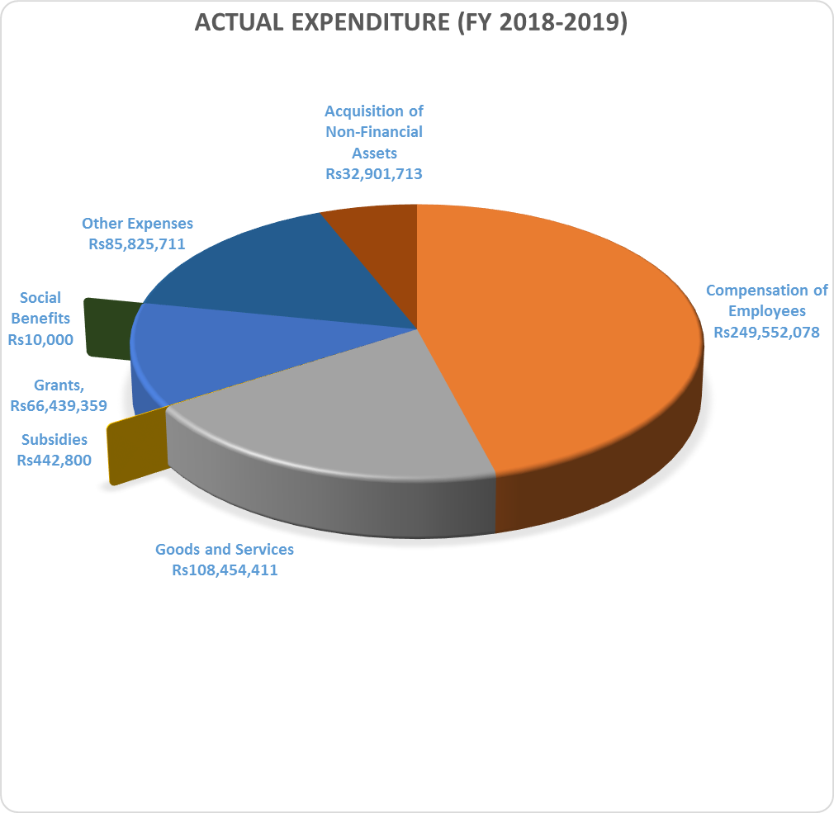

Figure 33 - Actual Expenditure for FY 2018-2019

Vote 20-1 Ocean Economy, Marine Resources and Shipping

Statement of Revenue for Vote 20-1
Table 14 gives the Statement of Revenue with regard to Vote 20-1 “Ocean Economy, Marine Resources and Shipping”.
STATEMENT OF REVENUE
SN | REVENUE | 2017-2018 ACTUAL (RS) | 2018-2019  ESTIMATES (RS) | 2018-2019 ACTUAL (RS)
1 | Shipping Fees | 5,022,892 | 5,070,000 | 6,150,621
2 | Miscellaneous (Shipping) | 5,892,490 | 6,100,000 | 5,628,824
 | Total | 10,915,382 | 11,170,000 | 11,779,445

Table 14 - Statement of Revenue for Vote 20-1 “Ocean Economy, Marine Resources and Shipping”
Note: As at 30 June 2019, an amount of Rs107,840 was outstanding.

Statement of Expenditure for Vote 20-1
Table 15 gives details of the Statement of Expenditure.
STATEMENT OF EXPENDITURE
SN | HEAD/SUB-HEAD OF EXPENDITURE | 2017-2018 ACTUAL (RS) | 2018-2019 ESTIMATES (RS) | 2018-2019  ACTUAL (RS)
1 | Compensation of Employees | 77,820,314 | 96,732,000 | 79,926,345
2 | Goods and Services | 48,542,864 | 104,643,000 | 59,966,791
3 | Subsidies | 462,600 | 500,000 | 442,800
4 | Recurrent Grants | 42,730,234 | 61,900,000 | 44,445,958
5 | Capital Grants | 34,329,500 | 15,600,000 | 10,662,113
6 | Social Benefits | 10,000 | 10,000 | 10,000
7 | Other Expenses | 75,255,350 | 75,315,000 | 75,265,019
8 | Acquisition of Non-Financial Assets | 8,172,830 | 2,300,000 | 162,403
 | Total | 287,323,692 | 357,000,000 | 270,881,429

Table 15 - Statement of Expenditure for Vote 20-1 “Ocean Economy, Marine Resources and Shipping”

Vote 20-2 Fisheries

Statement of Revenue for Vote 20-2
Table 16 gives the Statement of Revenue with regard to Vote 20-2 “Fisheries”.

STATEMENT OF REVENUE
SN | REVENUE | 2017-2018  ACTUAL (RS) | 2018-2019 ESTIMATES (RS) | 2018-2019 ACTUAL (RS)
1 | Fishing Vessel Licence | 63,061,733 | 64,000,000 | 81,540,170
2 | Fisheries Fees | 11,516,800 | 12,120,000 | 11,516,800
3 | Sale of Product | 37,000 | 35,000 | 436,196
4 | Miscellaneous (Fisheries) | 5,123,705 | 9,000,000 | 8,877,985
 | Total | 79,739,238 | 85,155,000 | 101,978,1511
Table 16 - Statement of Revenue for Vote 20-2 “Fisheries”

Statement of Expenditure for Vote 20-2
Table 17 gives the statement of expenditure with regard to Vote 20-2 “Fisheries”.
STATEMENT OF EXPENDITURE
SN | HEAD/SUB-HEAD OF EXPENDITURE | 2017-2018 ACTUAL (RS) | 2018-2019 ESTIMATES (RS) | 2018-2019  ACTUAL (RS)
1 | Compensation of Employees | 169,333,790 | 190,337,000 | 169,625,733
2 | Goods and Services | 40,972,425 | 60,563,000 | 48,487,620
3 | Subsidies | - | - | -
4 | Grants | 10,055,507 | 12,050,000 | 11,331,288
5 | Social Benefits | - | - | -
6 | Other Expenses | 20,045,212 | 18,450,000 | 10,560,692
7 | Acquisition of Non-Financial Assets | 27,245,050 | 60,600,000 | 32,739,310
 | Total | 267,651,984 | 342,000,000 | 272,744,643

Table 17 - Statement of Expenditure for Vote 20-2 “Fisheries”

Analysis of Major Changes

Revenue
In FY 2017-2018 Fishing Vessel Licence, Fisheries Fees and Miscellaneous (Fisheries) represented 88% of the total revenue collected and the remaining 12% were collected in respect of Shipping Fees and Miscellaneous (Shipping). Fishing Vessel Licence was the major component of revenue with a 70% share.

For the Financial Year 2018-2019, it was noted that 89% of the revenue collected was from the Fisheries Division and 11% was from the Shipping Division. Fishing Vessel Licence had remained the main component of revenue for the Ministry, which increased by 29% as compared to FY 2017-2018. It is also worth noting that Miscellaneous Revenue (Fisheries) increased by 73% as compared to FY 2017-2018, that is, from Rs5,123,705 to Rs8,877,985. Fishing Vessel Licence represents 70% of total revenue collected in FY 2018-2019.

Expenditure
In FY 2017-2018, 45% of expenditure incurred was under Compensation of Employees, 16% under Goods and Services, 16% under Subsidies and Grant, 17% under Other Expenses and the remaining 6% under Acquisition of Non-Financial Assets.

However, this tendency remained the same in FY 2018-2019, wherein 46% of expenditure had been incurred under Compensation of Employees, 20% under Goods and Services, 12% for Subsidies and Grants, 16% under Other Expenses and 6% only for Acquisition of Non-Financial Assets. A decrease of 2% is to be noted in overall expenditure in FY 2018-2019, which was Rs543,626,072 as compared to Rs554,975,676 in FY 2017-2018.

Trends and Challenges

Figure 34 - SWOT Analysis of the Ministry – Strengths and Weaknesses

Figure 35 - SWOT Analysis of the Ministry - Opportunities and Threats

Strategic Direction
(1) Manage ocean resources rationally
- Develop a Spatial Plan
(2) Ensure sustainable use of marine resources and regulate activities of the offshore
extractive industry
- Elaborate the legislative, regulatory and institutional frameworks
(3) Safeguard our territorial integrity and sovereignty and enhance maritime security
- Delimitate and map our maritime zones
- Reinforce appropriate logistics such as patrol vessels
(4) Develop local capacity in the sector
- Strengthen international and regional cooperation to secure assistance from key stakeholders and ensure transfer of knowledge
- Pursue Research and Development for the enhancement of aquaculture, marine renewable energy and marine biotechnology
(5) Promote employability in the maritime sector
- Develop new training courses to meet market demand

List of Acronyms
AFRC | - | Albion Fisheries Research Centre
CASF | - | Competent Authority Seafood
EEZ | - | Exclusive Economic Zone
EU | - | European Union
FAD | - | Fish Aggregating Devices
FiTEC | - | Fisheries Training and Extension Centre
FPS | - | Fisheries Protection Service
FY | - | Financial Year
GMDSS | - | Global Maritime Distress and Safety System
GRSE | - | Grand River South East
ILO | - | International Labour Organisation
IMO | - | International Maritime Organisation
IMSO | - | International Mobile Satellite Organisation
IOTC | - | Indian Ocean Tuna Commission
IUU | - | Illegal, Unreported and Unregulated
LRIT | - | Long Range Identification and Tracking of Ships
MAURITAS | - | Mauritius Accreditation Services
MCS | - | Monitoring, Control and Surveillance
MMTA | - | Mauritius Maritime Training Academy
MPA | - | Mauritius Ports Authority
MSA | - | Merchant Shipping Act
MSCL | - | Mauritius Shipping Corporation Limited
NGO | - | Non-Governmental Organisation
PBBS | - | Port Biological Baseline Survey
SOLAS | - | International Convention for the Safety of Life at Sea, 1974  (as amended)
STCW | - | International Convention on Standards of Training, Certification and Watchkeeping for Seafarers, 1978  (as amended)
VGM | - | Verified Gross Mass
VMS | - | Vessel Monitoring System

